|  |  |  |  |  |  |
| --- | --- | --- | --- | --- | --- |
| ITU logo | INTERNATIONAL TELECOMMUNICATION UNION  **TELECOMMUNICATION STANDARDIZATION SECTOR**  STUDY PERIOD 2017-2020 | | | SG13-TD421/WP2 | |
| **STUDY GROUP 13** | |
| **English only** | |
| **Question(s):** | | | 17/13 | Geneva, 28 June 2019 | |
| **TD** | | | | | |
| **Source:** | | | Editor | | |
| **Title:** | | | Draft revised Recommendation ITU-T Y.bdm-sch: Big data – Conceptual model of metadata Metadata | | |
| **Purpose:** | | | Proposal | | |
| **Contact:** | | Suwook Ha ETRI Korea (Republic of) | | | Tel: +82 42 860 5256 Fax: +82 42 861 5404 E-mail: sw.ha@etri.re.kr |

|  |  |
| --- | --- |
| **Keywords:** | Big data, metadata, catalogue, conceptual model |
| **Abstract:** | This document is a draft recommendation of Y.bdm-sch, “Big data – Metadata framework and conceptual model”. This document includes the results of discussion on the Q17/13 meeting which was held in Geneva, 17-28 June 2019. |

The following table shows discussion results for contributions.

|  |  |  |  |
| --- | --- | --- | --- |
| Contribution No. | Source | Contribution title | Result and action |
| C4 | ETRI | Y.bdm-sch: Modification of clause 6 | Accepted |
| C5 | ETRI | Y.bdm-sch: Modification of UML model in Appendix I | Accepted with modification |
| C6 | ETRI | Y.bdm-sch: Modification of XML schema in Appendix II and III | Accepted |
| C7 | ETRI | Y.bdm-sch: Modification of the tile and scope | Accepted |

During this meeting, it is agreed as follows:

* Modify the title and scope of draft recommendation;
* Modify clause 6 to fit for the target of this draft recommendation;
* Modify UML schema in Appendix I which related with managing a relationship between catalogues, and reflect the change to Appendix II;
* Modify XML schema in Appendix II and III.

It is recommended that future contributions cover following topics:

* Check summary and scope;
* Add a reference information about UML (e.g. ITU-T Z.109 Specification and Description Language – Unified modelling language profile for SDL-2010) at Appendix I
* Check a consistency of the draft recommendation for consent;
* Check typo, error, etc.
* But not limited to.

Attachment: Proposed text of draft Recommendation Y.bdm-sch.

**Draft Recommendation ITU-T Y.bdm-sch**

**Big data – Conceptual model of metadata**

**Summary**

Recommendation ITU-T Y.bdm-sch describes general concept of metadata and its utilization on a big data ecosystem. Also, this Recommendation provides a conceptual model of metadata to implementing metadata schema. This metadata supports finding data easier, and is used for preserving data, integrating data, and data history tracking, etc. by summarizing overall information about data.

**Keywords**

big data, big metadata, big data catalogue

**Contents**

**1 Scope 4**

**2 References 4**

**3 Definitions 4**

**4 Abbreviations and acronyms 4**

**5 Conventions 5**

**6 Overview 5**

**6.1 Metadata in the big data ecosystem 5**

**6.2 Metadata utilization on big data lifecycle 6**

**7 Metadata schemas 7**

**7.1 Structure and content of a data catalogue 7**

**7.2 Overview 8**

**7.3 Responsible party 8**

**7.4 Dataset information 9**

**7.5 Domain information 9**

**7.6 Data quality 9**

**7.7 Catalogue record 9**

**Appendix I. UML model 11**

**Appendix II. XML profile for metadata for big data 16**

**Appendix III. Examples of metadata instance 31**

**Bibliography 42**

**Big data – Conceptual model of metadata**

1. **Scope**

This Recommendation specifies conceptual model of metadata to support a big data ecosystem defined in [ITU-T Y.3600]. This Recommendation introduces metadata concept as well as its usages on a big data lifecycle. A UML model and XML schemas provided in the informative appendix are based on the conceptual model.

1. **References**

The following ITU-T Recommendations and other references contain provisions, which, through reference in this text, constitute provisions of this Recommendation. At the time of publication, the editions indicated were valid. All Recommendations and other references are subject to revision; users of this Recommendation are therefore encouraged to investigate the possibility of applying the most recent edition of the Recommendations and other references listed below. A list of the currently valid ITU-T Recommendations is regularly published.

The reference to a document within this Recommendation does not give it, as a stand-alone document, the status of a Recommendation.

[ITU-T Y.3600] Recommendation ITU-T Y.3600 (2015), *Big data – Cloud computing based requirements and capabilities.*

[ITU-T Y.3601] Recommendation ITU-T Y.3601 (2018), *Big data – Framework and requirements for data exchange.*

[ITU-T Y.3602] Recommendation ITU-T Y.3602 (2018), *Big data – Functional requirements for data provenance.*

1. **Definitions**
   1. **Terms defined elsewhere**

This Recommendation uses the following terms defined elsewhere:

* + 1. **data catalogue [ITU-T Y.3601]**: A listing of all metadata which a data broker makes available.
    2. **metadata [ITU-T H.752]:** structured, encoded data that describe characteristics of information-bearing entities to aid in the identification, discovery, assessment and management of the described entities.
    3. **metadata schema [ITU-T H.752]:** the representation format for a specifying data model describing target instances.
  1. **Terms defined in this Recommendation**

None.

1. **Abbreviations and acronyms**

This Recommendation uses the following abbreviations and acronyms:

API Application Programming Interface

BDSP Big Data Service Provider

DP Data Provider

UML Unified Modeling Language

URI Uniform Resource Identifier

URL Uniform Resource Locator

XML eXtensible Markup Language

1. **Conventions**

The keywords "**is required to**" indicate a requirement which must be strictly followed and from which no deviation is permitted if conformance to this document is to be claimed.

The keywords "**is recommended**" indicate a requirement which is recommended but which is not absolutely required. Thus this requirement need not be present to claim conformance.

The keywords "**can optionally**" indicate an optional requirement which is permissible, without implying any sense of being recommended. This term is not intended to imply that the vendor's implementation must provide the option and the feature can be optionally enabled by the network operator/service provider. Rather, it means the vendor may optionally provide the feature and still claim conformance with the specification.

In the body of this document and its annexes, the words shall, shall not, should, and may sometimes appear, in which case they are to be interpreted, respectively, as is required to, is prohibited from, is recommended, and can optionally. The appearance of such phrases or keywords in an appendix or in material explicitly marked as informative are to be interpreted as having no normative intent.

1. **Overview**
   1. **Metadata in the big data ecosystem**

Metadata is structured, encoded data that describe characteristics of information-bearing entities to aid in the identification, discovery, assessment and management of the described entities. Metadata summarizes overall information about data, making finding and working with particular data easier. Typically, the metadata structure is highly dependent on data format or application. Therefore, a metadata for big data is needed to provide an overarching model to cover the characteristics of big data.

Figure 6-1 illustrates metadata in the big data ecosystem defined in [ITU-T Y.3600]. Metadata is used for data publication and search among roles and sub-roles of the big data ecosystem.

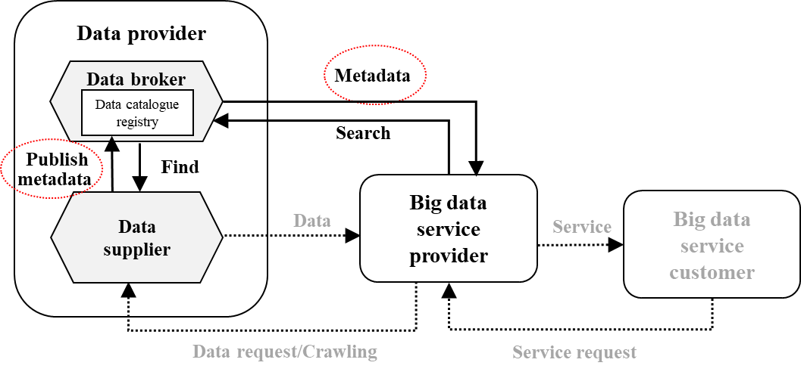

**Figure 6-1 Metadata in the big data ecosystem [ITU-T Y.3600]**

DP:data broker provides a meta-information registry (e.g. data catalogue registry) to DP:data suppliers for publishing their data sources, and DP:data suppliers are creating and publishing metadata information to DP:data broker. Big data service provider (BDSP) searches the necessary data through metadata stored in DP:data broker’s data catalogue registry.

According to [ITU-T Y.3600], metadata provides:

* critical information for identification, access right of data;
* information about creation, control and update on data for the management purpose;
* additional information about data integration capabilities.
  1. **Big data lifecycle and metadata utilizations**

Metadata is used for various purposes, such as preserving data, data distribution, data integration and data history management by continuously recoding and updating. Figure 6-2 shows the usages of metadata according to big data lifecycle.

NOTE – An example of big data lifecycle has a main cycle with creation/capture, storage, preparation, analysis, visualization, and also could have branch cycles with retirement/deletion, share/exchange.

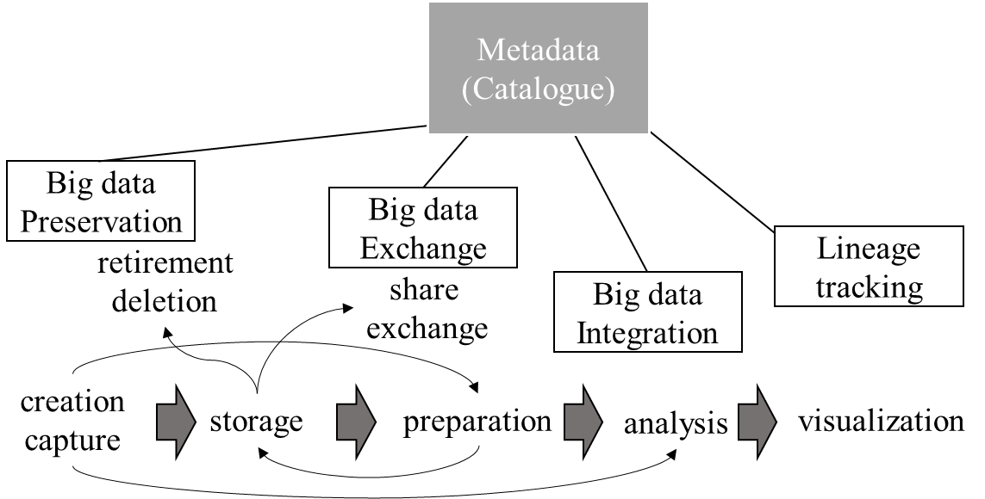

**Figure 6-2 Big data lifecycle and metadata utilization**

[ITU-T Y.3601] defines the functional requirements for big data exchange. In the recommendation, DP:data broker provides a common data catalogue schema to exchange big data which covers various type of data sources. DP:data broker provides meta-information (data catalogue for dataset) registry to data source. A data source publishes metadata to an online registry for data sharing. This common data catalogue includes:

* data type, format, size and its update frequency;
* category (area of data source);
* metadata and its access information (e.g. URI);
* delivery mechanism, and electronic access methods to data (e.g. API).

And, this catalogue may include:

* data rights (e.g. general agreement, copyrights, patents, licenses policies and pricing policies) (e.g. the applied functions with parameter);
* usage of data;
* quality of data (e.g. sales ranking, and data supplier’s credit);
* related keywords; and
* sample data.

Also, DP:data broker has to support data classification with commonly used data vocabulary and taxonomy, and recommended to support multiple data classifications by its areas of use.

[ITU-T Y.3602] defines the functional requirements for big data provenance. According to the recommendation, provenance is information about the origin and creation process of data with metadata recording process of workflow, annotations, notes about processes. When data is imported from an outside data source and stored, BDSP generates the metadata based on importing context including:

* responsible party information;
* time stamp; and
* size, etc.

This metadata can be used for recoding big data provenance unit which records a history of the most recent changes to the data.

For the storage efficiency and performance, BDSP provides data preservation capabilities by monitoring information (e.g. time stamp.) included in metadata. In addition, BDSP uses metadata to retrieve the target data for data preparation (e.g. data integration).

1. **Metadata schemas**
   1. **Structure and content of a data catalogue**

A data catalogue describes the requirements for searching dataset. It helps potential users to evaluate dataset to determine its suitability for use by them. This clause provides a structure and content of data catalogue for big data. Figure 7-1 shows the overall structure.

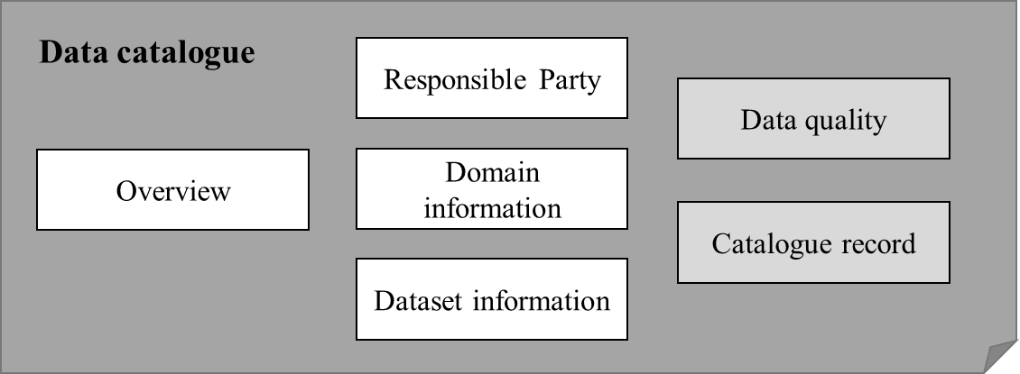

**Figure 7-1 Overall structure of metadata**

Data catalogue is required to contain major parts covering the following aspects of data:

* Overview (see clause 7.2);
* Responsible party (see clause 7.3);
* Dataset information (see clause 7.4)
* Domain information (see clause 7.5)

Data catalogue is recommended to contain part(s) covering the following aspects of data:

* Data quality (see clause 7.6)
* Catalogue record (see clause 7.7)

Each of these clauses of data catalogue is described in the following sub-clauses.

* 1. **Overview**

This part of data catalogue is required to include following:

* information about the creation of the data catalogue;

NOTE 1 – This may include the title, the language used in the text, and the version of data catalogue specification.

* an informal description of the data catalogue.

NOTE 2 – An informal description is intended to give a short introduction to data catalogue and allow a human reader a better understanding.

* 1. **Responsible party**

This part of data catalogue describes authoritative reference information, and is required to include following:

* information to identify and communicate with person(s) and organizations associated with the data catalogue.

NOTE 1 – This may include the role or function performed by the organization, the organization name, individual name, and position name.

This part of data catalogue is recommended to include following:

* contact information.

NOTE 2 – This may include phone number, address, online resource such as URI, and time period when individuals can contact the publisher of data catalogue.

* 1. **Dataset information**

A data catalogue contains one or more datasets. This part of data catalogue represents the actual dataset as published by the DP:data provider, and is required to include following:

* the title of the dataset;
* an informal description of the dataset.

NOTE 1 – An informal description is intended to give a short introduction to dataset and allow a human reader a better understanding.

This part of data catalogue is recommended to include following:

* dataset distribution information;

NOTE 2 – A dataset may have multiple distribution information.

NOTE 3 – This information may include the distribute format of dataset, type of dataset (structured, semi-structured, unstructured), access information including URL or user’s guide, size of dataset, sample data for user’s preview, and data rights.

* keywords representing dataset;
* contact point information.

NOTE 4 – Contact point information is represented with the same contents of responsible party in clause 7.3, but its target is DP:data provider.

Also, this part can contain this information optionally:

* the frequency at which the dataset is updated;
* temporal coverage of dataset which is described by period of time.

## Domain information

This part of data catalogue provides a domain information of dataset, and is required to include following:

* source domain of dataset for classification.

This part of data catalogue is recommended to include following:

* available usage domain of dataset.

## Data quality

In big data ecosystem, there are types and formats of data, and each data has different quality requirements. Therefore, different quality evaluation methods may be applied to different parts of the dataset. This part of data catalogue is required to include following:

* quality requirements on dataset;
* unit of measure for data quality;
* quality evaluation result.

## Catalogue record

This part of data catalogue provides a description of dataset’s entry in the catalogue, and is required to include following:

* the most resent modified date of data catalogue.

This part of data catalogue is recommended to include following:

* the issued date of listing the dataset in the catalogue.

NOTE – It is differing from the publication date of the dataset itself.

## Appendix I. UML model

(This appendix does not form an integral part of this Recommendation)

This appendix provides an example of a UML model based on clause 7 ‘Metadata schema’ which describes the requirements for data catalogue. Figure I-1 shows the overall class diagram of metadata for big data, and Table I.1 to I.7 show the corresponding data definitions.

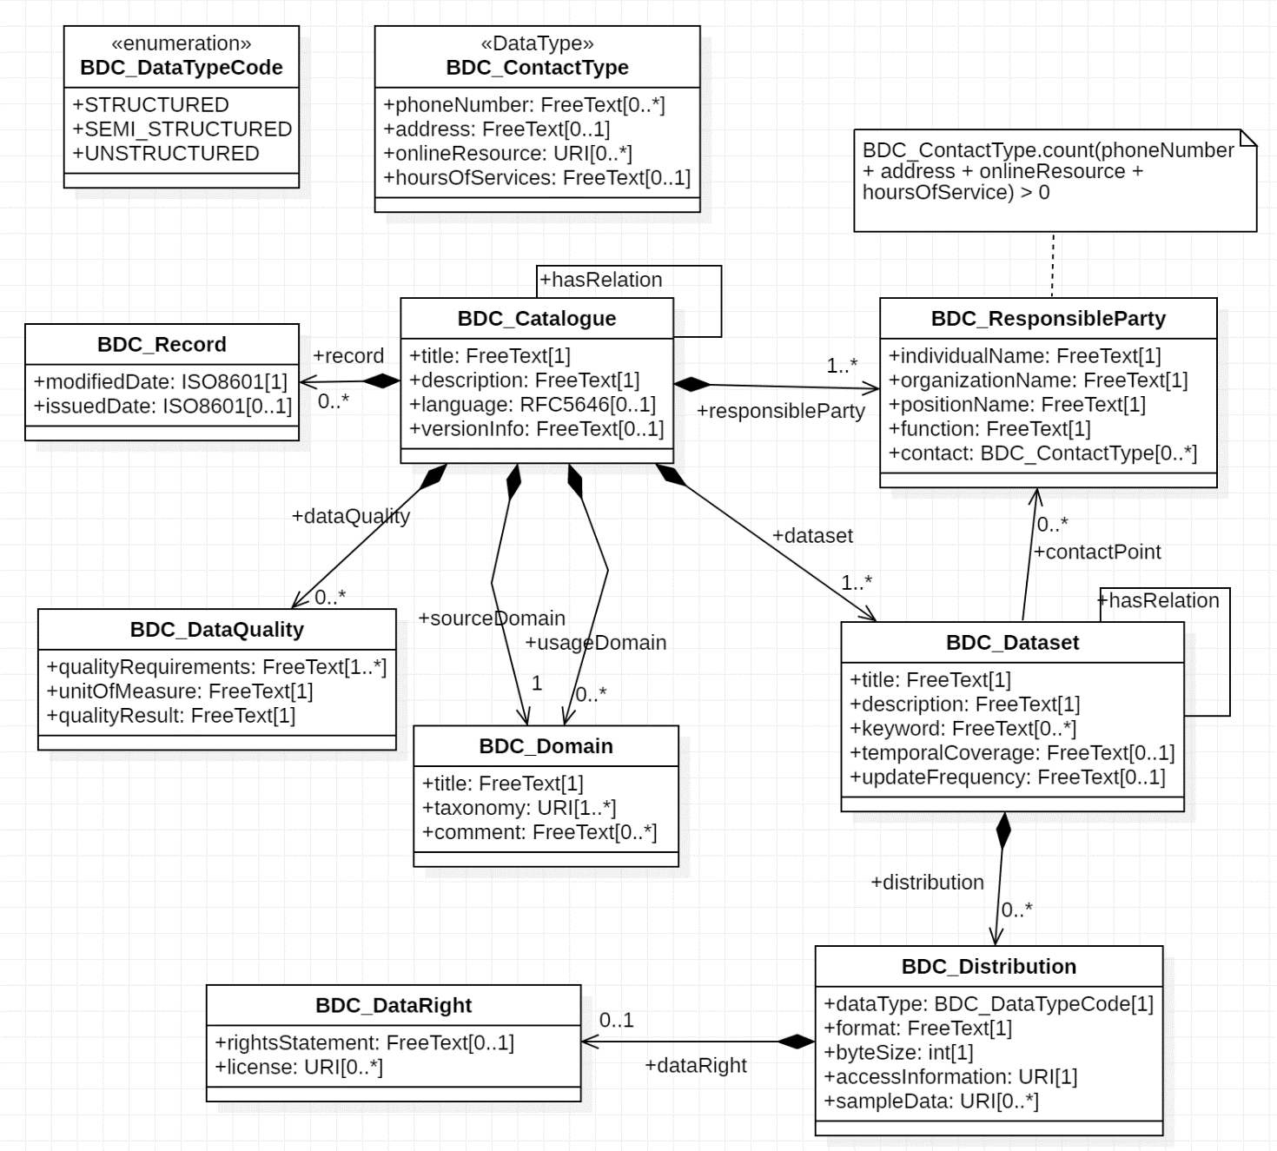

**Figure I-1 UML model of metadata for big data**

This is a descriptor whether a metadata entity shall always be documented in the metadata:

* M (Mandatory): Used for items that shall be supported;
* R (Recommended): Used for items should be supported;
* O (Optional): Used for items which may or may not be supported.

Cardinality specifies the maximum number of instances the metadata entity or the metadata element may have. Single occurrences are shown by “1”; repeating occurrences are represented by “N”.

For a metadata element, the domain specifies the values allowed or the use of free text. “Free text” indicates that no restrictions are placed on the contents of the field. Integer-based codes shall be used to represent values for domains containing codelists.

Table I-1 shows the data dictionary of *BDC_Catalogue* which describes overview information in clause 7.2.

**Table I-1 Catalogue overview**

|  |  |  |  |  |  |
| --- | --- | --- | --- | --- | --- |
|  | **Name/Role name** | **Description** | **M/R/O** | **Cardinality** | **Domain** |
| 1 | BDC_Catalogue | root entity which defines metadata about dataset resource | M | 1 | Line 2 to 12 |
| 2 | role: responsibleParty | responsible party information for the data catalogue | M | N | BDC_ResponsibleParty |
| 3 | role: dataset | dataset information for the data catalogue | M | N | BDC_Dataset |
| 4 | role: sourceDomain | source domain information for the data catalogue | M | 1 | BDC_Domain |
| 5 | role: usageDomain | usage domain information for the data catalogue | R | N | BDC_Domain |
| 6 | role: dataQuality | data quality information for the data catalogue | R | N | BDC_DataQuality |
| 7 | role: record | record information for the data catalogue | R | N | BDC_record |
| 8 | role: hasRelation | related data catalogue of the data catalogue | O | N | BDC_Catalogue |
| 9 | title | title of data catalogue | M | 1 | free text |
| 10 | description | a short introduction to data catalogue | M | 1 | free text |
| 11 | language | language used within the data catalogue | R | 1 | RFC 5646 |
| 12 | versionInfo | version of data catalogue specification | R | 1 | free text  (major.minor.patch) |

Table I-2 shows the data dictionary of *BDC*_*ResponsibleParty* and its data type class *BDC_ContactType* which describes the responsible party in clause 7.3.

**Table I-2 Responsible party information**

|  |  |  |  |  |  |
| --- | --- | --- | --- | --- | --- |
|  | **Name/Role name** | **Description** | **M/R/O** | **Cardinality** | **Domain** |
| 13 | BDC_ResponsibleParty | name and position information for an individual or organization that is responsible for the data catalogue or dataset | M | N | Line 14 to 18 |
| 14 | indivisualName | name of the responsible person- surname, given name, title | M | 1 | free text |
| 15 | organisationName | name of the responsible organization | M | 1 | free text |
| 16 | positionName | role or position of the responsible person | M | 1 | free text |
| 17 | role | function performed by the responsible party | M | 1 | free text |
| 18 | contact | information required to enable contact with the responsible person and/or organization | R | N | BDC_ContactType |
| 19 | BDC_ContactType | information required to enable contact with the responsible person and/or organization | R | N | Line 20 to 23 |
| 20 | phoneNumber | telephone numbers at which the organization or individual may be contacted | R | N | free text |
| 21 | address | physical and email address at which the organization or individual may be contacted | R | 1 | free text |
| 22 | onlineResource | on-line information that can be used to contact the individual or organization | R | N | URI |
| 23 | hoursOfServices | time period (including time zone) when individuals can contact the organization or individual | R | 1 | free text |

Table I-3 shows the data dictionary of *BDC_Dataset* and its sub-classes (*BDC_Distribution*, *BDC_DataRight*) which describes dataset information in clause 7.4.

**Table I-3 Dataset information**

|  |  |  |  |  |  |
| --- | --- | --- | --- | --- | --- |
|  | **Name/Role name** | **Description** | **M/R/O** | **Cardinality** | **Domain** |
| 24 | BDC_Dataset |  | M | N | Line 25 to 32 |
| 25 | role: contactPoint | contact point information for the dataset | R | N | BDC_ResponsibleParty |
| 26 | role: distribution | information about the distributor of and options for obtaining the dataset | R | N | BDC_Distribution |
| 27 | role: hasRelation | related dataset of the dataset | O | N | BDC_Dataset |
| 28 | title | title of the dataset | M | 1 | free text |
| 29 | description | a short introduction to the dataset | M | 1 | free text |
| 30 | keyword | commonly used word(s) used to describe the dataset | R | N | free text |
| 31 | temporalCoverage | time period (including time zone) when the dataset was captured | O | 1 | free text |
| 32 | updateFrequency | rate of occurrence of dataset update | O | 1 | free text |
| 33 | BDC_Distribution | information about the distributor of and options for obtaining the dataset | R | N | Line 34 to39 |
| 34 | role: dataRight | Information about limitation placed upon the use of the dataset | R | 1 | BDC_DataRight |
| 35 | dataType | the type information of the dataset | M | 1 | BDC_DataTypeCode |
| 36 | format | the format information of the dataset including a version | M | 1 | free text |
| 37 | byteSize | information about the size of dataset in bytes | M | 1 | int |
| 38 | accessInformation | access information to dataset | M | 1 | free text |
| 39 | sampleData | location information about a sample data including URL | R | N | URI |
| 40 | BDC_DataRight | information about limitation placed upon the use of the dataset | R | 1 | Line 41 to 42 |
| 41 | rightStatement | information to the usage permissions being agreed to | R | 1 | free text |
| 42 | license | This links to the license document under which the catalog is made available and not the datasets. | R | N | URI |

Table I-4 shows the data dictionary of *BDC_Domain* which describes domain information in clause 7.5.

**Table I-4 Domain information**

|  |  |  |  |  |  |
| --- | --- | --- | --- | --- | --- |
|  | **Name/Role name** | **Description** | **M/R/O** | **Cardinality** | **Domain** |
| 43 | BDC_Domain | source and/ or usage information for data catalogue | M | 1 | Line 44 to 46 |
| 44 | title | a member item of taxonomy which used for identifying the domain of source and /or usage | M | 1 | free text |
| 45 | taxonomy | taxonomy information including classification system and authority | M | N | URI |
| 46 | comment | an additional information for domain | O | N | free text |

Table I-5 shows the data dictionary of *BDC_DataQuality* which describes data quality in clause 7.6.

**Table I-5 Data quality information**

|  |  |  |  |  |  |
| --- | --- | --- | --- | --- | --- |
|  | **Name/Role name** | **Description** | **M/R/O** | **Cardinality** | **Domain** |
| 47 | BDC_DataQuality | data quality information for the data catalogue | R | N | Line 48 to 50 |
| 48 | qualityRequirements | requirement statement for evaluating quality of dataset | M | N | free text |
| 49 | unitOfMeausre | standard unit or system of units by means of which a quantity is accounted for and expressed. | M | 1 | free text |
| 50 | qualityResult | the result of quality evaluation described by the unit of measure | M | 1 | free text |

Table I-6 shows the data dictionary of *BDC_Record* which describes catalogue record in clause 7.7.

**Table I-6 Catalogue record information**

|  |  |  |  |  |  |
| --- | --- | --- | --- | --- | --- |
|  | **Name/Role name** | **Description** | **M/R/O** | **Cardinality** | **Domain** |
| 51 | BDC_Record | record information for the data catalogue | R | N | Line 52 to 53 |
| 52 | modifiedDate | the most resent modified date of data catalogue | M | N | ISO 8601 |
| 53 | issuedDate | the issued date of listing the dataset in the catalogue | R | 1 | ISO 8601 |

Table I- shows the data dictionary of *BDC_DataTypeCode* describing the enumerated data type for data distribution.

**Table I-7 <<Enumeration>> DataTypeCode**

|  |  |  |
| --- | --- | --- |
| **Concept name** | **Domain code** | **Definition** |
| STURECTURED | 001 | data that is organized in a format easily used by formatted repository |
| SEMI_STRUCTURED | 002 | data that is neither raw data, nor typed data in a conventional database system (e.g. XML, JSON) |
| UNDTRUCTURED | 003 | data that either does not have a pre-defined data model or is not organized in a pre-defined manner |

**Appendix II.   
XML profile for metadata for big data**

(This appendix does not form an integral part of this Recommendation)

This appendix provides XML schema with RDF and Turtle format corresponding to the UML model in Appendix I.

**II.1 Overview of W3C DCAT**

Data Catalog Vocabulary (DCAT) is W3C Recommendation published in 2014 [b-W3C DCAT]. It is an RDF vocabulary designed to facilitate interoperability between data catalogues published on the Web. In this Appendix, DCAT is used to create profiles because it has useful predicates for defining data catalogue, also this approach allows the ease conversion from an existing DCAT-based catalogue to an XML schema that supports this recommendation.

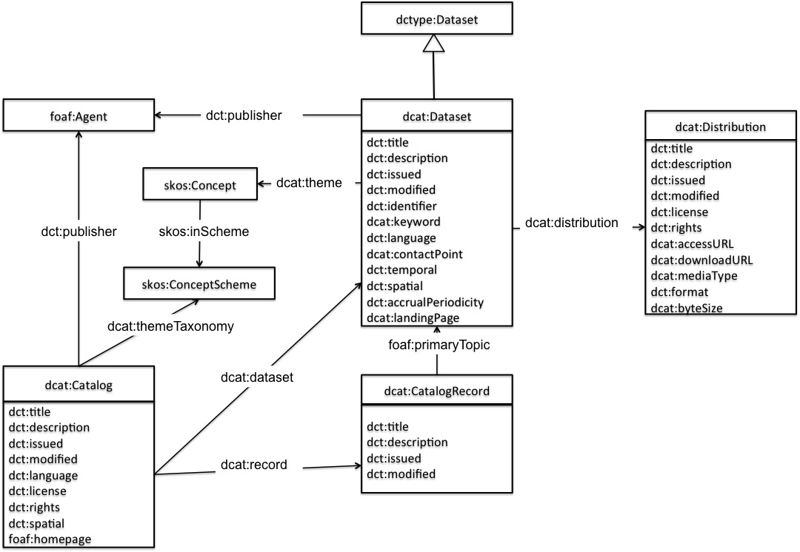

**Figure II-1 Overview of DCAT [b-W3C DCAT]**

The namespace for DCAT is http://www.w3.org/ns/dcat#, but DCAT makes extensive use of terms from other vocabularies. The extended prefix and its namespace for this Appendix are “bdc” and “http://www.itu.int/xml-namespace/itut/Y.bdm-sch/bigdatacatalogue#”.

**II.2 RDF schema**

[Editor’s Note on 2018-10-22] Namespace of Big data metadata schema should be fix for consent.

<?xml version="1.0"?>

<rdf:RDF xmlns="http://www.itu.int/xml-namespace/itut/Y.bdm-sch/bigdatacatalogue#"

xml:base="http://www.itu.int/xml-namespace/itut/Y.bdm-sch/bigdatacatalogue"

xmlns:schema="http://schema.org/"

xmlns:bdc="http://www.itu.int/xml-namespace/itut/Y.bdm-sch/bigdatacatalogue#"

xmlns:owl="http://www.w3.org/2002/07/owl#"

xmlns:xsd="http://www.w3.org/2001/XMLSchema#"

xmlns:rdfs="http://www.w3.org/2000/01/rdf-schema#"

xmlns:rdf="http://www.w3.org/1999/02/22-rdf-syntax-ns#"

xmlns:terms="http://purl.org/dc/terms/"

xmlns:xml="http://www.w3.org/XML/1998/namespace"

xmlns:dcat="http://www.w3.org/ns/dcat#"

xmlns:dc="http://purl.org/dc/elements/1.1/">

<owl:Ontology rdf:about="http://www.itu.int/xml-namespace/itut/Y.bdm-sch/bigdatacatalogue">

<owl:imports rdf:resource="http://www.w3.org/ns/dcat#"/>

<owl:imports rdf:resource="https://www.w3.org/2002/07/owl#"/>

</owl:Ontology>

<!--

///////////////////////////////////////////////////////////////////////////////////////

//

// Annotation properties

//

///////////////////////////////////////////////////////////////////////////////////////

-->

<!-- http://www.w3.org/2002/07/owl#versionInfo -->

<rdf:Description rdf:about="http://www.w3.org/2002/07/owl#versionInfo">

<rdfs:domain rdf:resource="http://www.itu.int/xml-namespace/itut/Y.bdm-sch/bigdatacatalogue#Catalogue"/>

</rdf:Description>

<!-- http://www.w3.org/ns/dcat#byteSize -->

<owl:AnnotationProperty rdf:about="http://www.w3.org/ns/dcat#byteSize">

<rdfs:domain rdf:resource="http://www.itu.int/xml-namespace/itut/Y.bdm-sch/bigdatacatalogue#Distribution"/>

</owl:AnnotationProperty>

<!--

///////////////////////////////////////////////////////////////////////////////////////

//

// Object Properties

//

///////////////////////////////////////////////////////////////////////////////////////

-->

<!-- http://purl.org/dc/elements/1.1/hasRelation -->

<owl:ObjectProperty rdf:about="http://purl.org/dc/elements/1.1/hasRelation">

<rdfs:domain rdf:resource="http://www.itu.int/xml-namespace/itut/Y.bdm-sch/bigdatacatalouge#Dataset"/>

<rdfs:range rdf:resource="http://www.itu.int/xml-namespace/itut/Y.bdm-sch/bigdatacatalouge#Dataset"/>

</owl:ObjectProperty>

<owl:ObjectProperty rdf:about="http://purl.org/dc/elements/1.1/hasRelation">

<rdfs:domain rdf:resource="http://www.itu.int/xml-namespace/itut/Y.bdm-sch/bigdatacatalogue#Catalogue"/>

<rdfs:range rdf:resource="http://www.itu.int/xml-namespace/itut/Y.bdm-sch/bigdatacatalogue#Catalogue"/>

</owl:ObjectProperty>

<!-- http://www.itu.int/xml-namespace/itut/Y.bdm-sch/bigdatacatalogue#contact -->

<owl:ObjectProperty rdf:about="http://www.itu.int/xml-namespace/itut/Y.bdm-sch/bigdatacatalogue#contact">

<rdfs:domain rdf:resource="http://www.itu.int/xml-namespace/itut/Y.bdm-sch/bigdatacatalogue#ResponsibleParty"/>

<rdfs:range rdf:resource="http://www.itu.int/xml-namespace/itut/Y.bdm-sch/bigdatacatalogue#ContactType"/>

<rdfs:comment>information required to enable contact with the responsible person and/or organization</rdfs:comment>

</owl:ObjectProperty>

<!-- http://www.itu.int/xml-namespace/itut/Y.bdm-sch/bigdatacatalogue#contactPoint -->

<owl:ObjectProperty rdf:about="http://www.itu.int/xml-namespace/itut/Y.bdm-sch/bigdatacatalogue#contactPoint">

<rdfs:domain rdf:resource="http://www.itu.int/xml-namespace/itut/Y.bdm-sch/bigdatacatalogue#Dataset"/>

<rdfs:range rdf:resource="http://www.itu.int/xml-namespace/itut/Y.bdm-sch/bigdatacatalogue#ResponsibleParty"/>

<rdfs:comment>data quality information for the data catalogue</rdfs:comment>

</owl:ObjectProperty>

<!-- http://www.itu.int/xml-namespace/itut/Y.bdm-sch/bigdatacatalogue#dataQuality -->

<owl:ObjectProperty rdf:about="http://www.itu.int/xml-namespace/itut/Y.bdm-sch/bigdatacatalogue#dataQuality">

<rdfs:domain rdf:resource="http://www.itu.int/xml-namespace/itut/Y.bdm-sch/bigdatacatalogue#Catalogue"/>

<rdfs:range rdf:resource="http://www.itu.int/xml-namespace/itut/Y.bdm-sch/bigdatacatalogue#DataQuality"/>

<rdfs:comment>Information about limitation placed upon the use of the dataset</rdfs:comment>

</owl:ObjectProperty>

<!-- http://www.itu.int/xml-namespace/itut/Y.bdm-sch/bigdatacatalogue#dataRight -->

<owl:ObjectProperty rdf:about="http://www.itu.int/xml-namespace/itut/Y.bdm-sch/bigdatacatalogue#dataRight">

<rdfs:domain rdf:resource="http://www.itu.int/xml-namespace/itut/Y.bdm-sch/bigdatacatalogue#Distribution"/>

<rdfs:range rdf:resource="http://www.itu.int/xml-namespace/itut/Y.bdm-sch/bigdatacatalogue#DataRight"/>

<rdfs:comment>Information about limitation placed upon the use of the dataset</rdfs:comment>

</owl:ObjectProperty>

<!-- http://www.itu.int/xml-namespace/itut/Y.bdm-sch/bigdatacatalogue#dataType -->

<owl:ObjectProperty rdf:about="http://www.itu.int/xml-namespace/itut/Y.bdm-sch/bigdatacatalogue#dataType">

<rdfs:domain rdf:resource="http://www.itu.int/xml-namespace/itut/Y.bdm-sch/bigdatacatalogue#Distribution"/>

<rdfs:range rdf:resource="http://www.itu.int/xml-namespace/itut/Y.bdm-sch/bigdatacatalogue#DataTypeCode"/>

<rdfs:comment>the type information of the dataset</rdfs:comment>

</owl:ObjectProperty>

<!-- http://www.itu.int/xml-namespace/itut/Y.bdm-sch/bigdatacatalogue#dataset -->

<owl:ObjectProperty rdf:about="http://www.itu.int/xml-namespace/itut/Y.bdm-sch/bigdatacatalogue#dataset">

<rdfs:domain rdf:resource="http://www.itu.int/xml-namespace/itut/Y.bdm-sch/bigdatacatalogue#Catalogue"/>

<rdfs:range rdf:resource="http://www.itu.int/xml-namespace/itut/Y.bdm-sch/bigdatacatalogue#Dataset"/>

<rdfs:comment>dataset information for the data catalogue</rdfs:comment>

</owl:ObjectProperty>

<!-- http://www.itu.int/xml-namespace/itut/Y.bdm-sch/bigdatacatalogue#distribution -->

<owl:ObjectProperty rdf:about="http://www.itu.int/xml-namespace/itut/Y.bdm-sch/bigdatacatalogue#distribution">

<rdfs:domain rdf:resource="http://www.itu.int/xml-namespace/itut/Y.bdm-sch/bigdatacatalogue#Dataset"/>

<rdfs:range rdf:resource="http://www.itu.int/xml-namespace/itut/Y.bdm-sch/bigdatacatalogue#Distribution"/>

<rdfs:comment>information about the distributor of and options for obtaining the dataset</rdfs:comment>

</owl:ObjectProperty>

<!-- http://www.itu.int/xml-namespace/itut/Y.bdm-sch/bigdatacatalogue#record -->

<owl:ObjectProperty rdf:about="http://www.itu.int/xml-namespace/itut/Y.bdm-sch/bigdatacatalogue#record">

<rdfs:domain rdf:resource="http://www.itu.int/xml-namespace/itut/Y.bdm-sch/bigdatacatalogue#Catalogue"/>

<rdfs:range rdf:resource="http://www.itu.int/xml-namespace/itut/Y.bdm-sch/bigdatacatalogue#Record"/>

<rdfs:comment>record information for the data catalogue</rdfs:comment>

</owl:ObjectProperty>

<!-- http://www.itu.int/xml-namespace/itut/Y.bdm-sch/bigdatacatalogue#responsibleParty -->

<owl:ObjectProperty rdf:about="http://www.itu.int/xml-namespace/itut/Y.bdm-sch/bigdatacatalogue#responsibleParty">

<rdfs:domain rdf:resource="http://www.itu.int/xml-namespace/itut/Y.bdm-sch/bigdatacatalogue#Catalogue"/>

<rdfs:range rdf:resource="http://www.itu.int/xml-namespace/itut/Y.bdm-sch/bigdatacatalogue#ResponsibleParty"/>

<rdfs:comment>responsible party information for the data catalogue</rdfs:comment>

</owl:ObjectProperty>

<!-- http://www.itu.int/xml-namespace/itut/Y.bdm-sch/bigdatacatalogue#sourceDomain -->

<owl:ObjectProperty rdf:about="http://www.itu.int/xml-namespace/itut/Y.bdm-sch/bigdatacatalogue#sourceDomain">

<rdfs:domain rdf:resource="http://www.itu.int/xml-namespace/itut/Y.bdm-sch/bigdatacatalogue#Catalogue"/>

<rdfs:range rdf:resource="http://www.itu.int/xml-namespace/itut/Y.bdm-sch/bigdatacatalogue#Domain"/>

<rdfs:comment>source domain information for the data catalogue</rdfs:comment>

</owl:ObjectProperty>

<!-- http://www.itu.int/xml-namespace/itut/Y.bdm-sch/bigdatacatalogue#usageDomain -->

<owl:ObjectProperty rdf:about="http://www.itu.int/xml-namespace/itut/Y.bdm-sch/bigdatacatalogue#usageDomain">

<rdfs:domain rdf:resource="http://www.itu.int/xml-namespace/itut/Y.bdm-sch/bigdatacatalogue#Catalogue"/>

<rdfs:range rdf:resource="http://www.itu.int/xml-namespace/itut/Y.bdm-sch/bigdatacatalogue#Domain"/>

<rdfs:comment>usage domain information for the data catalogue</rdfs:comment>

</owl:ObjectProperty>

<!--

///////////////////////////////////////////////////////////////////////////////////////

//

// Data properties

//

///////////////////////////////////////////////////////////////////////////////////////

-->

<!-- http://purl.org/dc/elements/1.1/description -->

<owl:DatatypeProperty rdf:about="http://purl.org/dc/elements/1.1/description">

<rdfs:domain rdf:resource="http://www.itu.int/xml-namespace/itut/Y.bdm-sch/bigdatacatalogue#Catalogue"/>

<rdfs:domain rdf:resource="http://www.itu.int/xml-namespace/itut/Y.bdm-sch/bigdatacatalogue#Dataset"/>

<rdfs:range rdf:resource="http://www.w3.org/2001/XMLSchema#string"/>

</owl:DatatypeProperty>

<!-- http://purl.org/dc/elements/1.1/format -->

<owl:DatatypeProperty rdf:about="http://purl.org/dc/elements/1.1/format">

<rdfs:domain rdf:resource="http://www.itu.int/xml-namespace/itut/Y.bdm-sch/bigdatacatalogue#Distribution"/>

<rdfs:range rdf:resource="http://www.w3.org/2001/XMLSchema#string"/>

</owl:DatatypeProperty>

<!-- http://purl.org/dc/elements/1.1/keyword -->

<owl:DatatypeProperty rdf:about="http://purl.org/dc/elements/1.1/keyword">

<rdfs:domain rdf:resource="http://www.itu.int/xml-namespace/itut/Y.bdm-sch/bigdatacatalogue#Dataset"/>

<rdfs:range rdf:resource="http://www.w3.org/2001/XMLSchema#string"/>

<rdfs:comment>commonly used word(s) used to describe the dataset</rdfs:comment>

</owl:DatatypeProperty>

<!-- http://purl.org/dc/elements/1.1/language -->

<owl:DatatypeProperty rdf:about="http://purl.org/dc/elements/1.1/language">

<rdfs:domain rdf:resource="http://www.itu.int/xml-namespace/itut/Y.bdm-sch/bigdatacatalogue#Catalogue"/>

<rdfs:range rdf:resource="http://purl.org/dc/terms/RFC5646"/>

</owl:DatatypeProperty>

<!-- http://purl.org/dc/elements/1.1/temporalCoverage -->

<owl:DatatypeProperty rdf:about="http://purl.org/dc/elements/1.1/temporalCoverage">

<rdfs:domain rdf:resource="http://www.itu.int/xml-namespace/itut/Y.bdm-sch/bigdatacatalogue#Dataset"/>

<rdfs:range rdf:resource="http://www.w3.org/2001/XMLSchema#string"/>

<rdfs:comment>time period (including time zone) when the dataset was captured</rdfs:comment>

</owl:DatatypeProperty>

<!-- http://purl.org/dc/elements/1.1/title -->

<owl:DatatypeProperty rdf:about="http://purl.org/dc/elements/1.1/title">

<rdfs:domain rdf:resource="http://www.itu.int/xml-namespace/itut/Y.bdm-sch/bigdatacatalogue#Catalogue"/>

<rdfs:domain rdf:resource="http://www.itu.int/xml-namespace/itut/Y.bdm-sch/bigdatacatalogue#Dataset"/>

<rdfs:domain rdf:resource="http://www.itu.int/xml-namespace/itut/Y.bdm-sch/bigdatacatalogue#Domain"/>

<rdfs:range rdf:resource="http://www.w3.org/2001/XMLSchema#string"/>

</owl:DatatypeProperty>

<!-- http://purl.org/dc/elements/1.1/updateFrequency -->

<owl:DatatypeProperty rdf:about="http://purl.org/dc/elements/1.1/updateFrequency">

<rdfs:domain rdf:resource="http://www.itu.int/xml-namespace/itut/Y.bdm-sch/bigdatacatalogue#Dataset"/>

<rdfs:range rdf:resource="http://www.w3.org/2001/XMLSchema#string"/>

<rdfs:comment>rate of occurrence of dataset update</rdfs:comment>

</owl:DatatypeProperty>

<!-- http://www.itu.int/xml-namespace/itut/Y.bdm-sch/bigdatacatalogue#accessInformation -->

<owl:DatatypeProperty rdf:about="http://www.itu.int/xml-namespace/itut/Y.bdm-sch/bigdatacatalogue#accessInformation">

<rdfs:domain rdf:resource="http://www.itu.int/xml-namespace/itut/Y.bdm-sch/bigdatacatalogue#Distribution"/>

<rdfs:range rdf:resource="http://www.w3.org/2001/XMLSchema#string"/>

<rdfs:comment>access information to dataset</rdfs:comment>

</owl:DatatypeProperty>

<!-- http://www.itu.int/xml-namespace/itut/Y.bdm-sch/bigdatacatalogue#address -->

<owl:DatatypeProperty rdf:about="http://www.itu.int/xml-namespace/itut/Y.bdm-sch/bigdatacatalogue#address">

<rdfs:domain rdf:resource="http://www.itu.int/xml-namespace/itut/Y.bdm-sch/bigdatacatalogue#ContactType"/>

<rdfs:range rdf:resource="http://www.w3.org/2001/XMLSchema#string"/>

<rdfs:comment>physical and email address at which the organization or individual may be contacted</rdfs:comment>

</owl:DatatypeProperty>

<!-- http://www.itu.int/xml-namespace/itut/Y.bdm-sch/bigdatacatalogue#hoursOfServices -->

<owl:DatatypeProperty rdf:about="http://www.itu.int/xml-namespace/itut/Y.bdm-sch/bigdatacatalogue#hoursOfServices">

<rdfs:domain rdf:resource="http://www.itu.int/xml-namespace/itut/Y.bdm-sch/bigdatacatalogue#ContactType"/>

<rdfs:range rdf:resource="http://www.w3.org/2001/XMLSchema#string"/>

<rdfs:comment>time period (including time zone) when individuals can contact the organization or individual</rdfs:comment>

</owl:DatatypeProperty>

<!-- http://www.itu.int/xml-namespace/itut/Y.bdm-sch/bigdatacatalogue#individualName -->

<owl:DatatypeProperty rdf:about="http://www.itu.int/xml-namespace/itut/Y.bdm-sch/bigdatacatalogue#individualName">

<rdfs:domain rdf:resource="http://www.itu.int/xml-namespace/itut/Y.bdm-sch/bigdatacatalogue#ResponsibleParty"/>

<rdfs:range rdf:resource="http://www.w3.org/2001/XMLSchema#string"/>

<rdfs:comment>name of the responsible person- surname, given name, title</rdfs:comment>

</owl:DatatypeProperty>

<!-- http://www.itu.int/xml-namespace/itut/Y.bdm-sch/bigdatacatalogue#issuedDate -->

<owl:DatatypeProperty rdf:about="http://www.itu.int/xml-namespace/itut/Y.bdm-sch/bigdatacatalogue#issuedDate">

<rdfs:domain rdf:resource="http://www.itu.int/xml-namespace/itut/Y.bdm-sch/bigdatacatalogue#Record"/>

<rdfs:range rdf:resource="http://www.w3.org/2001/XMLSchema#date"/>

<rdfs:comment>the issued date of listing the dataset in the catalogue</rdfs:comment>

</owl:DatatypeProperty>

<!-- http://www.itu.int/xml-namespace/itut/Y.bdm-sch/bigdatacatalogue#license -->

<owl:DatatypeProperty rdf:about="http://www.itu.int/xml-namespace/itut/Y.bdm-sch/bigdatacatalogue#license">

<rdfs:domain rdf:resource="http://www.itu.int/xml-namespace/itut/Y.bdm-sch/bigdatacatalogue#DataRight"/>

<rdfs:range rdf:resource="http://www.w3.org/2001/XMLSchema#anyURI"/>

<rdfs:comment>This links to the license document under which the catalog is made available and not the datasets</rdfs:comment>

</owl:DatatypeProperty>

<!-- http://www.itu.int/xml-namespace/itut/Y.bdm-sch/bigdatacatalogue#modifiedDate -->

<owl:DatatypeProperty rdf:about="http://www.itu.int/xml-namespace/itut/Y.bdm-sch/bigdatacatalogue#modifiedDate">

<rdfs:domain rdf:resource="http://www.itu.int/xml-namespace/itut/Y.bdm-sch/bigdatacatalogue#Record"/>

<rdfs:range rdf:resource="http://www.w3.org/2001/XMLSchema#date"/>

<rdfs:comment>the most resent modified date of data catalogue</rdfs:comment>

</owl:DatatypeProperty>

<!-- http://www.itu.int/xml-namespace/itut/Y.bdm-sch/bigdatacatalogue#onlineResource -->

<owl:DatatypeProperty rdf:about="http://www.itu.int/xml-namespace/itut/Y.bdm-sch/bigdatacatalogue#onlineResource">

<rdfs:domain rdf:resource="http://www.itu.int/xml-namespace/itut/Y.bdm-sch/bigdatacatalogue#ContactType"/>

<rdfs:range rdf:resource="http://www.w3.org/2001/XMLSchema#anyURI"/>

<rdfs:comment>online information that can be used to contact the individual or organization</rdfs:comment>

</owl:DatatypeProperty>

<!-- http://www.itu.int/xml-namespace/itut/Y.bdm-sch/bigdatacatalogue#organizationName -->

<owl:DatatypeProperty rdf:about="http://www.itu.int/xml-namespace/itut/Y.bdm-sch/bigdatacatalogue#organizationName">

<rdfs:domain rdf:resource="http://www.itu.int/xml-namespace/itut/Y.bdm-sch/bigdatacatalogue#ResponsibleParty"/>

<rdfs:range rdf:resource="http://www.w3.org/2001/XMLSchema#string"/>

<rdfs:comment>name of the responsible organization</rdfs:comment>

</owl:DatatypeProperty>

<!-- http://www.itu.int/xml-namespace/itut/Y.bdm-sch/bigdatacatalogue#phoneNumber -->

<owl:DatatypeProperty rdf:about="http://www.itu.int/xml-namespace/itut/Y.bdm-sch/bigdatacatalogue#phoneNumber">

<rdfs:domain rdf:resource="http://www.itu.int/xml-namespace/itut/Y.bdm-sch/bigdatacatalogue#ContactType"/>

<rdfs:range rdf:resource="http://www.w3.org/2001/XMLSchema#string"/>

<rdfs:comment>telephone numbers at which the organization or individual may be contacted</rdfs:comment>

</owl:DatatypeProperty>

<!-- http://www.itu.int/xml-namespace/itut/Y.bdm-sch/bigdatacatalogue#positionName -->

<owl:DatatypeProperty rdf:about="http://www.itu.int/xml-namespace/itut/Y.bdm-sch/bigdatacatalogue#positionName">

<rdfs:domain rdf:resource="http://www.itu.int/xml-namespace/itut/Y.bdm-sch/bigdatacatalogue#ResponsibleParty"/>

<rdfs:range rdf:resource="http://www.w3.org/2001/XMLSchema#string"/>

<rdfs:comment>role or position of the responsible person</rdfs:comment>

</owl:DatatypeProperty>

<!-- http://www.itu.int/xml-namespace/itut/Y.bdm-sch/bigdatacatalogue#qualityRequirements -->

<owl:DatatypeProperty rdf:about="http://www.itu.int/xml-namespace/itut/Y.bdm-sch/bigdatacatalogue#qualityRequirements">

<rdfs:domain rdf:resource="http://www.itu.int/xml-namespace/itut/Y.bdm-sch/bigdatacatalogue#DataQuality"/>

<rdfs:range rdf:resource="http://www.w3.org/2001/XMLSchema#string"/>

<rdfs:comment>requirement statement for evaluating quality of dataset</rdfs:comment>

</owl:DatatypeProperty>

<!-- http://www.itu.int/xml-namespace/itut/Y.bdm-sch/bigdatacatalogue#qualityResult -->

<owl:DatatypeProperty rdf:about="http://www.itu.int/xml-namespace/itut/Y.bdm-sch/bigdatacatalogue#qualityResult">

<rdfs:domain rdf:resource="http://www.itu.int/xml-namespace/itut/Y.bdm-sch/bigdatacatalogue#DataQuality"/>

<rdfs:range rdf:resource="http://www.w3.org/2001/XMLSchema#string"/>

<rdfs:comment>the result of quality evaluation described by the unit of measure</rdfs:comment>

</owl:DatatypeProperty>

<!-- http://www.itu.int/xml-namespace/itut/Y.bdm-sch/bigdatacatalogue#rightStatement -->

<owl:DatatypeProperty rdf:about="http://www.itu.int/xml-namespace/itut/Y.bdm-sch/bigdatacatalogue#rightStatement">

<rdfs:domain rdf:resource="http://www.itu.int/xml-namespace/itut/Y.bdm-sch/bigdatacatalogue#DataRight"/>

<rdfs:range rdf:resource="http://www.w3.org/2001/XMLSchema#string"/>

<rdfs:comment>information to the usage permissions being agreed to</rdfs:comment>

</owl:DatatypeProperty>

<!-- http://www.itu.int/xml-namespace/itut/Y.bdm-sch/bigdatacatalogue#function -->

<owl:DatatypeProperty rdf:about="http://www.itu.int/xml-namespace/itut/Y.bdm-sch/bigdatacatalogue#function">

<rdfs:domain rdf:resource="http://www.itu.int/xml-namespace/itut/Y.bdm-sch/bigdatacatalogue#ResponsibleParty"/>

<rdfs:range rdf:resource="http://www.w3.org/2001/XMLSchema#string"/>

<rdfs:comment>function performed by the responsible party</rdfs:comment>

</owl:DatatypeProperty>

<!-- http://www.itu.int/xml-namespace/itut/Y.bdm-sch/bigdatacatalogue#sampleData -->

<owl:DatatypeProperty rdf:about="http://www.itu.int/xml-namespace/itut/Y.bdm-sch/bigdatacatalogue#sampleData">

<rdfs:domain rdf:resource="http://www.itu.int/xml-namespace/itut/Y.bdm-sch/bigdatacatalogue#Distribution"/>

<rdfs:range rdf:resource="http://www.w3.org/2001/XMLSchema#anyURI"/>

<rdfs:comment>location information about a sample data including URL</rdfs:comment>

</owl:DatatypeProperty>

<!-- http://www.itu.int/xml-namespace/itut/Y.bdm-sch/bigdatacatalogue#taxonomy -->

<owl:DatatypeProperty rdf:about="http://www.itu.int/xml-namespace/itut/Y.bdm-sch/bigdatacatalogue#taxonomy">

<rdfs:domain rdf:resource="http://www.itu.int/xml-namespace/itut/Y.bdm-sch/bigdatacatalogue#Domain"/>

<rdfs:range rdf:resource="http://www.w3.org/2001/XMLSchema#anyURI"/>

<rdfs:comment>taxonomy information including classification system and authority</rdfs:comment>

</owl:DatatypeProperty>

<!-- http://www.itu.int/xml-namespace/itut/Y.bdm-sch/bigdatacatalogue#unitOfMeasure -->

<owl:DatatypeProperty rdf:about="http://www.itu.int/xml-namespace/itut/Y.bdm-sch/bigdatacatalogue#unitOfMeasure">

<rdfs:domain rdf:resource="http://www.itu.int/xml-namespace/itut/Y.bdm-sch/bigdatacatalogue#DataQuality"/>

<rdfs:range rdf:resource="http://www.w3.org/2001/XMLSchema#string"/>

<rdfs:comment>standard unit or system of units by means of which a quantity is accounted for and expressed.</rdfs:comment>

</owl:DatatypeProperty>

<!--

///////////////////////////////////////////////////////////////////////////////////////

//

// Classes

//

///////////////////////////////////////////////////////////////////////////////////////

-->

<!-- http://www.itu.int/xml-namespace/itut/Y.bdm-sch/bigdatacatalogue#Catalogue -->

<owl:Class rdf:about="http://www.itu.int/xml-namespace/itut/Y.bdm-sch/bigdatacatalogue#Catalogue">

<rdfs:subClassOf rdf:resource="http://www.w3.org/2002/07/owl#Thing"/>

<rdfs:comment>Root entity which defines metadata about dataset resource</rdfs:comment>

</owl:Class>

<!-- http://www.itu.int/xml-namespace/itut/Y.bdm-sch/bigdatacatalogue#ContactType -->

<owl:Class rdf:about="http://www.itu.int/xml-namespace/itut/Y.bdm-sch/bigdatacatalogue#ContactType">

<rdfs:subClassOf rdf:resource="http://www.w3.org/2002/07/owl#Thing"/>

<rdfs:comment>information required to enable contact with the responsible person and/or organization</rdfs:comment>

</owl:Class>

<!-- http://www.itu.int/xml-namespace/itut/Y.bdm-sch/bigdatacatalogue#DataQuality -->

<owl:Class rdf:about="http://www.itu.int/xml-namespace/itut/Y.bdm-sch/bigdatacatalogue#DataQuality">

<rdfs:subClassOf rdf:resource="http://www.w3.org/2002/07/owl#Thing"/>

<rdfs:comment>data quality information for the data catalogue</rdfs:comment>

</owl:Class>

<!-- http://www.itu.int/xml-namespace/itut/Y.bdm-sch/bigdatacatalogue#DataRight -->

<owl:Class rdf:about="http://www.itu.int/xml-namespace/itut/Y.bdm-sch/bigdatacatalogue#DataRight">

<rdfs:subClassOf rdf:resource="http://www.w3.org/2002/07/owl#Thing"/>

<rdfs:comment>information about limitation placed upon the use of the dataset</rdfs:comment>

</owl:Class>

<!-- http://www.itu.int/xml-namespace/itut/Y.bdm-sch/bigdatacatalogue#DataTypeCode -->

<owl:Class rdf:about="http://www.itu.int/xml-namespace/itut/Y.bdm-sch/bigdatacatalogue#DataTypeCode">

<rdfs:subClassOf rdf:resource="http://www.w3.org/2002/07/owl#Thing"/>

</owl:Class>

<!-- http://www.itu.int/xml-namespace/itut/Y.bdm-sch/bigdatacatalogue#Dataset -->

<owl:Class rdf:about="http://www.itu.int/xml-namespace/itut/Y.bdm-sch/bigdatacatalogue#Dataset">

<rdfs:subClassOf rdf:resource="http://www.w3.org/2002/07/owl#Thing"/>

<rdfs:comment>dataset information for the data catalogue</rdfs:comment>

</owl:Class>

<!-- http://www.itu.int/xml-namespace/itut/Y.bdm-sch/bigdatacatalogue#Distribution -->

<owl:Class rdf:about="http://www.itu.int/xml-namespace/itut/Y.bdm-sch/bigdatacatalogue#Distribution">

<rdfs:subClassOf rdf:resource="http://www.w3.org/2002/07/owl#Thing"/>

<rdfs:comment>information about the distributor of and options for obtaining the dataset</rdfs:comment>

</owl:Class>

<!-- http://www.itu.int/xml-namespace/itut/Y.bdm-sch/bigdatacatalogue#Domain -->

<owl:Class rdf:about="http://www.itu.int/xml-namespace/itut/Y.bdm-sch/bigdatacatalogue#Domain">

<rdfs:subClassOf rdf:resource="http://www.w3.org/2002/07/owl#Thing"/>

<rdfs:comment>source and/ or usage information for data catalogue</rdfs:comment>

</owl:Class>

<!-- http://www.itu.int/xml-namespace/itut/Y.bdm-sch/bigdatacatalogue#Record -->

<owl:Class rdf:about="http://www.itu.int/xml-namespace/itut/Y.bdm-sch/bigdatacatalogue#Record">

<rdfs:subClassOf rdf:resource="http://www.w3.org/2002/07/owl#Thing"/>

<rdfs:comment>record information for the data catalogue</rdfs:comment>

</owl:Class>

<!-- http://www.itu.int/xml-namespace/itut/Y.bdm-sch/bigdatacatalogue#ResponsibleParty -->

<owl:Class rdf:about="http://www.itu.int/xml-namespace/itut/Y.bdm-sch/bigdatacatalogue#ResponsibleParty">

<rdfs:subClassOf rdf:resource="http://www.w3.org/2002/07/owl#Thing"/>

<rdfs:comment>responsible party information for the data catalogue</rdfs:comment>

</owl:Class>

<!-- http://www.itu.int/xml-namespace/itut/Y.bdm-sch/bigdatacatalogue#SemiStructured -->

<owl:Class rdf:about="http://www.itu.int/xml-namespace/itut/Y.bdm-sch/bigdatacatalogue#SemiStructured">

<rdfs:subClassOf rdf:resource="http://www.w3.org/2002/07/owl#Thing"/>

</owl:Class>

<!-- http://www.itu.int/xml-namespace/itut/Y.bdm-sch/bigdatacatalogue#Structured -->

<owl:Class rdf:about="http://www.itu.int/xml-namespace/itut/Y.bdm-sch/bigdatacatalogue#Structured">

<rdfs:subClassOf rdf:resource="http://www.w3.org/2002/07/owl#Thing"/>

</owl:Class>

<!-- http://www.itu.int/xml-namespace/itut/Y.bdm-sch/bigdatacatalogue#Unstructured -->

<owl:Class rdf:about="http://www.itu.int/xml-namespace/itut/Y.bdm-sch/bigdatacatalogue#Unstructured">

<rdfs:subClassOf rdf:resource="http://www.w3.org/2002/07/owl#Thing"/>

</owl:Class>

<!--

///////////////////////////////////////////////////////////////////////////////////////

//

// Individuals

//

///////////////////////////////////////////////////////////////////////////////////////

-->

<!-- http://www.itu.int/xml-namespace/itut/Y.bdm-sch/bigdatacatalogue#SemiStructured -->

<owl:NamedIndividual rdf:about="http://www.itu.int/xml-namespace/itut/Y.bdm-sch/bigdatacatalogue#SemiStructured">

<rdf:type rdf:resource="http://www.itu.int/xml-namespace/itut/Y.bdm-sch/bigdatacatalogue#DataTypeCode"/>

<rdfs:comment>data that is neither raw data, nor typed data in a conventional database system (e.g. XML, JSON)</rdfs:comment>

</owl:NamedIndividual>

<!-- http://www.itu.int/xml-namespace/itut/Y.bdm-sch/bigdatacatalogue#Structured -->

<owl:NamedIndividual rdf:about="http://www.itu.int/xml-namespace/itut/Y.bdm-sch/bigdatacatalogue#Structured">

<rdf:type rdf:resource="http://www.itu.int/xml-namespace/itut/Y.bdm-sch/bigdatacatalogue#DataTypeCode"/>

<rdfs:comment>data that is organized in a format easily used by formatted repository</rdfs:comment>

</owl:NamedIndividual>

<!-- http://www.itu.int/xml-namespace/itut/Y.bdm-sch/bigdatacatalogue#Unstructured -->

<owl:NamedIndividual rdf:about="http://www.itu.int/xml-namespace/itut/Y.bdm-sch/bigdatacatalogue#Unstructured">

<rdf:type rdf:resource="http://www.itu.int/xml-namespace/itut/Y.bdm-sch/bigdatacatalogue#DataTypeCode"/>

<rdfs:comment>data that either does not have a pre-defined data model or is not organized in a pre-defined manner</rdfs:comment>

</owl:NamedIndividual>

</rdf:RDF>

**II.3 RDF Turtle schema**

# baseURI: http://www.itu.int/xml-namespace/itut/Y.bdm-sch/bigdatacatalogue

# imports: http://purl.org/dc/elements/1.1/

# imports: http://purl.org/dc/terms/

# imports: http://www.w3.org/ns/dcat#

# imports: https://www.w3.org/2002/07/owl#

# prefix: bdc

@prefix bdc: <http://www.itu.int/xml-namespace/itut/Y.bdm-sch/bigdatacatalogue#> .

@prefix owl: <http://www.w3.org/2002/07/owl#> .

@prefix rdf: <http://www.w3.org/1999/02/22-rdf-syntax-ns#> .

@prefix rdfs: <http://www.w3.org/2000/01/rdf-schema#> .

@prefix xsd: <http://www.w3.org/2001/XMLSchema#> .

<http://purl.org/dc/elements/1.1/description>

rdfs:domain bdc:Catalogue ;

rdfs:domain bdc:Dataset ;

rdfs:range xsd:string ;

.

<http://purl.org/dc/elements/1.1/format>

rdfs:domain bdc:Distribution ;

rdfs:range xsd:string ;

.

<http://purl.org/dc/elements/1.1/hasRelation>

rdf:type rdf:Property ;

rdfs:domain bdc:Dataset ;

rdfs:range bdc:Dataset ;

.

<http://purl.org/dc/elements/1.1/hasRelation>

rdf:type rdf:Property ;

rdfs:domain bdc:Catalogue ;

rdfs:range bdc:Catalogue ;

.

<http://purl.org/dc/elements/1.1/keyword>

rdf:type rdf:Property ;

rdfs:comment "commonly used word(s) used to describe the dataset" ;

rdfs:domain bdc:Dataset ;

rdfs:range xsd:string ;

.

<http://purl.org/dc/elements/1.1/language>

rdfs:domain bdc:Catalogue ;

rdfs:range <http://purl.org/dc/terms/RFC5646> ;

.

<http://purl.org/dc/elements/1.1/temporalCoverage>

rdf:type rdf:Property ;

rdfs:comment "time period (including time zone) when the dataset was captured" ;

rdfs:domain bdc:Dataset ;

rdfs:range xsd:string ;

.

<http://purl.org/dc/elements/1.1/title>

rdfs:domain bdc:Catalogue ;

rdfs:domain bdc:Dataset ;

rdfs:domain bdc:Domain ;

rdfs:range xsd:string ;

.

<http://purl.org/dc/elements/1.1/updateFrequency>

rdf:type rdf:Property ;

rdfs:comment "rate of occurrence of dataset update" ;

rdfs:domain bdc:Dataset ;

rdfs:range xsd:string ;

.

<http://www.itu.int/xml-namespace/itut/Y.bdm-sch/bigdatacatalogue>

rdf:type owl:Ontology ;

owl:imports <http://purl.org/dc/elements/1.1/> ;

owl:imports <http://purl.org/dc/terms/> ;

owl:imports <http://www.w3.org/ns/dcat#> ;

owl:imports <https://www.w3.org/2002/07/owl#> ;

.

bdc:Catalogue

rdf:type rdfs:Class ;

rdfs:comment "Root entity which defines metadata about dataset resource" ;

rdfs:subClassOf owl:Thing ;

.

bdc:ContactType

rdf:type rdfs:Class ;

rdfs:comment "information required to enable contact with the responsible person and/or organization" ;

rdfs:subClassOf owl:Thing ;

.

bdc:DataQuality

rdf:type rdfs:Class ;

rdfs:comment "data quality information for the data catalogue" ;

rdfs:subClassOf owl:Thing ;

.

bdc:DataRight

rdf:type rdfs:Class ;

rdfs:comment "information about limitation placed upon the use of the dataset" ;

rdfs:subClassOf owl:Thing ;

.

bdc:DataTypeCode

rdf:type rdfs:Class ;

rdfs:subClassOf owl:Thing ;

.

bdc:Dataset

rdf:type rdfs:Class ;

rdfs:comment "dataset information for the data catalogue" ;

rdfs:subClassOf owl:Thing ;

.

bdc:Distribution

rdf:type rdfs:Class ;

rdfs:comment "information about the distributor of and options for obtaining the dataset" ;

rdfs:subClassOf owl:Thing ;

.

bdc:Domain

rdf:type rdfs:Class ;

rdfs:comment "source and/ or usage information for data catalogue" ;

rdfs:subClassOf owl:Thing ;

.

bdc:Record

rdf:type rdfs:Class ;

rdfs:comment "record information for the data catalogue" ;

rdfs:subClassOf owl:Thing ;

.

bdc:ResponsibleParty

rdf:type rdfs:Class ;

rdfs:comment "responsible party information for the data catalogue" ;

rdfs:subClassOf owl:Thing ;

.

bdc:SemiStructured

rdf:type bdc:DataTypeCode ;

rdfs:comment "data that is neither raw data, nor typed data in a conventional database system (e.g. XML, JSON)" ;

rdfs:subClassOf owl:Thing ;

.

bdc:Structured

rdf:type bdc:DataTypeCode ;

rdfs:comment "data that is organized in a format easily used by formatted repository" ;

rdfs:subClassOf owl:Thing ;

.

bdc:Unstructured

rdf:type bdc:DataTypeCode ;

rdfs:comment "data that either does not have a pre-defined data model or is not organized in a pre-defined manner" ;

rdfs:subClassOf owl:Thing ;

.

bdc:accessInformation

rdf:type owl:DatatypeProperty ;

rdfs:comment "access information to dataset" ;

rdfs:domain bdc:Distribution ;

rdfs:range xsd:string ;

.

bdc:address

rdf:type rdf:Property ;

rdfs:comment "physical and email address at which the organization or individual may be contacted" ;

rdfs:domain bdc:ContactType ;

rdfs:range xsd:string ;

.

bdc:contact

rdf:type rdf:Property ;

rdfs:comment "information required to enable contact with the responsible person and/or organization" ;

rdfs:domain bdc:ResponsibleParty ;

rdfs:range bdc:ContactType ;

.

bdc:contactPoint

rdf:type rdf:Property ;

rdfs:comment "contact point information for the dataset" ;

rdfs:domain bdc:Dataset ;

rdfs:range bdc:ResponsibleParty ;

.

bdc:dataQuality

rdf:type rdf:Property ;

rdfs:comment "data quality information for the data catalogue" ;

rdfs:domain bdc:Catalogue ;

rdfs:range bdc:DataQuality ;

.

bdc:dataRight

rdf:type rdf:Property ;

rdfs:comment "Information about limitation placed upon the use of the dataset" ;

rdfs:domain bdc:Distribution ;

rdfs:range bdc:DataRight ;

.

bdc:dataType

rdf:type rdf:Property ;

rdfs:comment "the type information of the dataset" ;

rdfs:domain bdc:Distribution ;

rdfs:range bdc:DataTypeCode ;

.

bdc:dataset

rdf:type rdf:Property ;

rdfs:comment "dataset information for the data catalogue" ;

rdfs:domain bdc:Catalogue ;

rdfs:range bdc:Dataset ;

.

bdc:distribution

rdf:type rdf:Property ;

rdfs:comment "information about the distributor of and options for obtaining the dataset" ;

rdfs:domain bdc:Dataset ;

rdfs:range bdc:Distribution ;

.

bdc:hoursOfServices

rdf:type rdf:Property ;

rdfs:comment "time period (including time zone) when individuals can contact the organization or individual" ;

rdfs:domain bdc:ContactType ;

rdfs:range xsd:string ;

.

bdc:individualName

rdf:type rdf:Property ;

rdfs:comment "name of the responsible person- surname, given name, title" ;

rdfs:domain bdc:ResponsibleParty ;

rdfs:range xsd:string ;

.

bdc:issuedDate

rdf:type rdf:Property ;

rdfs:comment "the issued date of listing the dataset in the catalogue" ;

rdfs:domain bdc:Record ;

rdfs:range xsd:date ;

.

bdc:license

rdf:type rdf:Property ;

rdfs:comment "This links to the license document under which the catalog is made available and not the datasets" ;

rdfs:domain bdc:DataRight ;

rdfs:range xsd:anyURI ;

.

bdc:modifiedDate

rdf:type rdf:Property ;

rdfs:comment "the most resent modified date of data catalogue" ;

rdfs:domain bdc:Record ;

rdfs:range xsd:date ;

.

bdc:onlineResource

rdf:type rdf:Property ;

rdfs:comment "online information that can be used to contact the individual or organization" ;

rdfs:domain bdc:ContactType ;

rdfs:range xsd:anyURI ;

.

bdc:organizationName

rdf:type rdf:Property ;

rdfs:comment "name of the responsible organization" ;

rdfs:domain bdc:ResponsibleParty ;

rdfs:range xsd:string ;

.

bdc:phoneNumber

rdf:type rdf:Property ;

rdfs:comment "telephone numbers at which the organization or individual may be contacted" ;

rdfs:domain bdc:ContactType ;

rdfs:range xsd:string ;

.

bdc:positionName

rdf:type rdf:Property ;

rdfs:comment "role or position of the responsible person" ;

rdfs:domain bdc:ResponsibleParty ;

rdfs:range xsd:string ;

.

bdc:qualityRequirements

rdf:type rdf:Property ;

rdfs:comment "requirement statement for evaluating quality of dataset" ;

rdfs:domain bdc:DataQuality ;

rdfs:range xsd:string ;

.

bdc:qualityResult

rdf:type rdf:Property ;

rdfs:comment "the result of quality evaluation described by the unit of measure" ;

rdfs:domain bdc:DataQuality ;

rdfs:range xsd:string ;

.

bdc:record

rdf:type rdf:Property ;

rdfs:comment "record information for the data catalogue" ;

rdfs:domain bdc:Catalogue ;

rdfs:range bdc:Record ;

.

bdc:responsibleParty

rdf:type rdf:Property ;

rdfs:comment "responsible party information for the data catalogue" ;

rdfs:domain bdc:Catalogue ;

rdfs:range bdc:ResponsibleParty ;

.

bdc:rightStatement

rdf:type rdf:Property ;

rdfs:comment "information to the usage permissions being agreed to" ;

rdfs:domain bdc:DataRight ;

rdfs:range xsd:string ;

.

bdc:function

rdf:type rdf:Property ;

rdfs:comment "function performed by the responsible party" ;

rdfs:domain bdc:ResponsibleParty ;

rdfs:range xsd:string ;

.

bdc:sampleData

rdf:type owl:DatatypeProperty ;

rdfs:comment "location information about a sample data including URL" ;

rdfs:domain bdc:Distribution ;

rdfs:range xsd:anyURI ;

.

bdc:sourceDomain

rdf:type rdf:Property ;

rdfs:comment "source domain information for the data catalogue" ;

rdfs:domain bdc:Catalogue ;

rdfs:range bdc:Domain ;

.

bdc:taxonomy

rdf:type rdf:Property ;

rdfs:comment "taxonomy information including classification system and authority" ;

rdfs:domain bdc:Domain ;

rdfs:range xsd:anyURI ;

.

bdc:unitOfMeasure

rdf:type rdf:Property ;

rdfs:comment "standard unit or system of units by means of which a quantity is accounted for and expressed." ;

rdfs:domain bdc:DataQuality ;

rdfs:range xsd:string ;

.

bdc:usageDomain

rdf:type rdf:Property ;

rdfs:comment "usage domain information for the data catalogue" ;

rdfs:domain bdc:Catalogue ;

rdfs:range bdc:Domain ;

.

owl:versionInfo

rdfs:domain bdc:Catalogue ;

.

<http://www.w3.org/ns/dcat#byteSize>

rdfs:domain bdc:Distribution ;

.

**Appendix III. Examples of metadata instance**

(This appendix does not form an integral part of this Recommendation)

For the better understanding of the conceptual model, this appendix provides the examples of metadata instance about health care data ([www.nhis.or.kr](http://www.nhis.or.kr)). The UML object diagram, RDF instance and Turtle instances follow the UML and XML model in Appendix I and II, and these examples provide same information on dataset about ‘Health Insurance’.

**III.1 UML object diagram**

The object diagram represents an instance of a class diagram. Figure III-1 is an object diagram derived from class diagram presented by Figure I-1.

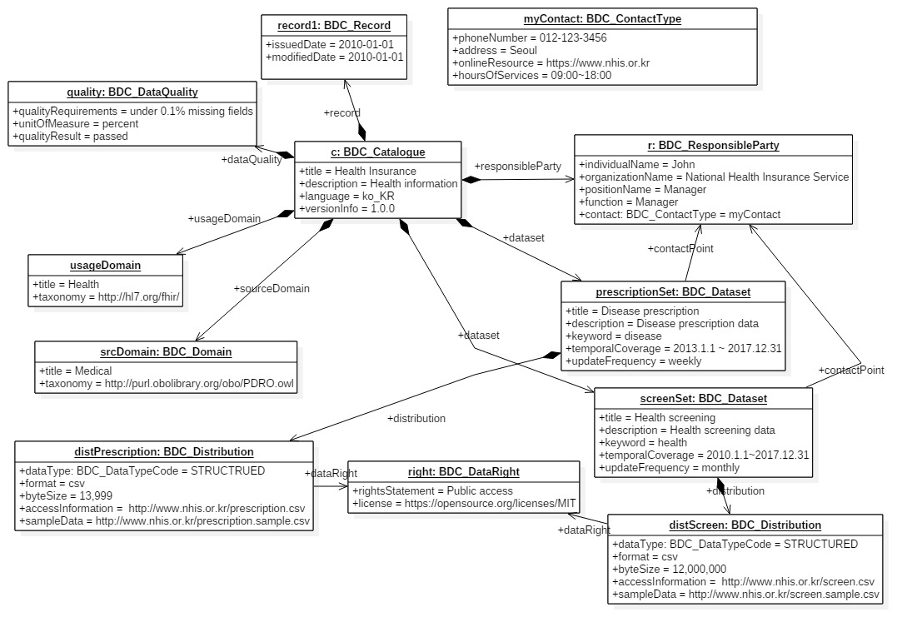

**Figure III-1 UML object diagram of metadata**

**III.2 RDF instance**

This clause provides an example of metadata instance based on the RDF schema which described in Appendix II.2.

<?xml version="1.0"?>

<rdf:RDF xmlns="http://www.itu.int/xml-namespace/itut/Y.bdm-sch/bigdatacatalogue#"

xml:base="http://www.itu.int/xml-namespace/itut/Y.bdm-sch/bigdatacatalogue"

xmlns:schema="http://schema.org/"

xmlns:bdc="http://www.itu.int/xml-namespace/itut/Y.bdm-sch/bigdatacatalogue#"

xmlns:owl="http://www.w3.org/2002/07/owl#"

xmlns:xsd="http://www.w3.org/2001/XMLSchema#"

xmlns:rdfs="http://www.w3.org/2000/01/rdf-schema#"

xmlns:dct="http://purl.org/dc/terms/"

xmlns:rdf="http://www.w3.org/1999/02/22-rdf-syntax-ns#"

xmlns:xml="http://www.w3.org/XML/1998/namespace"

xmlns:dcat="http://www.w3.org/ns/dcat#"

xmlns:dc="http://purl.org/dc/elements/1.1/">

<owl:Ontology rdf:about="http://www.itu.int/xml-namespace/itut/Y.bdm-sch/bigdatacatalogue">

<owl:imports rdf:resource="http://www.w3.org/ns/dcat#"/>

<owl:imports rdf:resource="https://www.w3.org/2002/07/owl#"/>

</owl:Ontology>

<!-- http://www.itu.int/xml-namespace/itut/Y.bdm-sch/bigdatacatalogue#healthCatalogue -->

<owl:NamedIndividual rdf:about="http://www.itu.int/xml-namespace/itut/Y.bdm-sch/bigdatacatalogue#healthCatalogue">

<rdf:type rdf:resource="http://www.itu.int/xml-namespace/itut/Y.bdm-sch/bigdatacatalogue#Catalogue"/>

<dataQuality rdf:resource="http://www.itu.int/xml-namespace/itut/Y.bdm-sch/bigdatacatalogue#quality"/>

<dataset rdf:resource="http://www.itu.int/xml-namespace/itut/Y.bdm-sch/bigdatacatalogue#prescriptionSet"/>

<dataset rdf:resource="http://www.itu.int/xml-namespace/itut/Y.bdm-sch/bigdatacatalogue#screenSet"/>

<record rdf:resource="http://www.itu.int/xml-namespace/itut/Y.bdm-sch/bigdatacatalogue#record1"/>

<responsibleParty rdf:resource="http://www.itu.int/xml-namespace/itut/Y.bdm-sch/bigdatacatalogue#rParty"/>

<sourceDomain rdf:resource="http://www.itu.int/xml-namespace/itut/Y.bdm-sch/bigdatacatalogue#srcDomain"/>

<usageDomain rdf:resource="http://www.itu.int/xml-namespace/itut/Y.bdm-sch/bigdatacatalogue#useDomain"/>

<dc:description>Health data of prescription &amp; screening</dc:description>

<dc:language rdf:datatype="http://purl.org/dc/terms/RFC5646">ko_KR</dc:language>

<dc:title>Health Data</dc:title>

<owl:versionInfo>1.0.0</owl:versionInfo>

</owl:NamedIndividual>

<!-- http://www.itu.int/xml-namespace/itut/Y.bdm-sch/bigdatacatalogue#ko_KR -->

<owl:NamedIndividual rdf:about="http://www.itu.int/xml-namespace/itut/Y.bdm-sch/bigdatacatalogue#ko_KR">

<rdf:type rdf:resource="http://purl.org/dc/terms/LinguisticSystem"/>

</owl:NamedIndividual>

<!-- http://www.itu.int/xml-namespace/itut/Y.bdm-sch/bigdatacatalogue#myContact -->

<owl:NamedIndividual rdf:about="http://www.itu.int/xml-namespace/itut/Y.bdm-sch/bigdatacatalogue#myContact">

<rdf:type rdf:resource="http://www.itu.int/xml-namespace/itut/Y.bdm-sch/bigdatacatalogue#ContactType"/>

<address>Seoul Korea</address>

<hoursOfServices>09:00~18:00</hoursOfServices>

<onlineResource rdf:datatype="http://www.w3.org/2001/XMLSchema#anyURI">https://www.nhis.or.kr</onlineResource>

<phoneNumber>012-123-3456</phoneNumber>

</owl:NamedIndividual>

<!-- http://www.itu.int/xml-namespace/itut/Y.bdm-sch/bigdatacatalogue#prescriptionDist -->

<owl:NamedIndividual rdf:about="http://www.itu.int/xml-namespace/itut/Y.bdm-sch/bigdatacatalogue#prescriptionDist">

<rdf:type rdf:resource="http://www.itu.int/xml-namespace/itut/Y.bdm-sch/bigdatacatalogue#Distribution"/>

<dataRight rdf:resource="http://www.itu.int/xml-namespace/itut/Y.bdm-sch/bigdatacatalogue#right"/>

<dataType rdf:resource="http://www.itu.int/xml-namespace/itut/Y.bdm-sch/bigdatacatalogue#Structured"/>

<dc:format>csv</dc:format>

<accessInformation rdf:datatype="http://www.w3.org/2001/XMLSchema#anyURI">http://www.nhis.or.kr/prescription.csv</accessInformation>

<sampleData rdf:datatype="http://www.w3.org/2001/XMLSchema#anyURI">http://www.nhis.or.kr/prescription.sample.csv</sampleData>

<dcat:byteSize rdf:datatype="http://www.w3.org/2001/XMLSchema#unsignedLong">3999200</dcat:byteSize>

</owl:NamedIndividual>

<!-- http://www.itu.int/xml-namespace/itut/Y.bdm-sch/bigdatacatalogue#prescriptionSet -->

<owl:NamedIndividual rdf:about="http://www.itu.int/xml-namespace/itut/Y.bdm-sch/bigdatacatalogue#prescriptionSet">

<rdf:type rdf:resource="http://www.itu.int/xml-namespace/itut/Y.bdm-sch/bigdatacatalogue#Dataset"/>

<contactPoint rdf:resource="http://www.itu.int/xml-namespace/itut/Y.bdm-sch/bigdatacatalogue#rParty"/>

<dc:description>Disease prescription data</dc:description>

<dc:keyword>prescription</dc:keyword>

<dc:temporalCoverage>2013.1.1 ~ 2017.12.31</dc:temporalCoverage>

<dc:updateFrequency>weekly</dc:updateFrequency>

<dc:title>Disease prescription</dc:title>

</owl:NamedIndividual>

<!-- http://www.itu.int/xml-namespace/itut/Y.bdm-sch/bigdatacatalogue#quality -->

<owl:NamedIndividual rdf:about="http://www.itu.int/xml-namespace/itut/Y.bdm-sch/bigdatacatalogue#quality">

<rdf:type rdf:resource="http://www.itu.int/xml-namespace/itut/Y.bdm-sch/bigdatacatalogue#DataQuality"/>

<qualityRequirements>under 1% missing fields</qualityRequirements>

<qualityResult>passed (99.3%)</qualityResult>

<unitOfMeasure>percent</unitOfMeasure>

</owl:NamedIndividual>

<!-- http://www.itu.int/xml-namespace/itut/Y.bdm-sch/bigdatacatalogue#rParty -->

<owl:NamedIndividual rdf:about="http://www.itu.int/xml-namespace/itut/Y.bdm-sch/bigdatacatalogue#rParty">

<rdf:type rdf:resource="http://www.itu.int/xml-namespace/itut/Y.bdm-sch/bigdatacatalogue#ResponsibleParty"/>

<contact rdf:resource="http://www.itu.int/xml-namespace/itut/Y.bdm-sch/bigdatacatalogue#myContact"/>

<function>Management</function>

<individualName>John</individualName>

<organizationName>National Health Insurance Service</organizationName>

<positionName>Manager</positionName>

</owl:NamedIndividual>

<!-- http://www.itu.int/xml-namespace/itut/Y.bdm-sch/bigdatacatalogue#record1 -->

<owl:NamedIndividual rdf:about="http://www.itu.int/xml-namespace/itut/Y.bdm-sch/bigdatacatalogue#record1">

<rdf:type rdf:resource="http://www.itu.int/xml-namespace/itut/Y.bdm-sch/bigdatacatalogue#Record"/>

<issuedDate rdf:datatype="http://www.w3.org/2001/XMLSchema#date">2018-03-01</issuedDate>

<modifiedDate rdf:datatype="http://www.w3.org/2001/XMLSchema#date">2018-04-15</modifiedDate>

</owl:NamedIndividual>

<!-- http://www.itu.int/xml-namespace/itut/Y.bdm-sch/bigdatacatalogue#right -->

<owl:NamedIndividual rdf:about="http://www.itu.int/xml-namespace/itut/Y.bdm-sch/bigdatacatalogue#right">

<rdf:type rdf:resource="http://www.itu.int/xml-namespace/itut/Y.bdm-sch/bigdatacatalogue#DataRight"/>

<license rdf:datatype="http://www.w3.org/2001/XMLSchema#anyURI">http://purl.obolibrary.org/obo/PDRO.owl</license>

<rightsStatement>Public access</rightsStatement>

</owl:NamedIndividual>

<!-- http://www.itu.int/xml-namespace/itut/Y.bdm-sch/bigdatacatalogue#screenDist -->

<owl:NamedIndividual rdf:about="http://www.itu.int/xml-namespace/itut/Y.bdm-sch/bigdatacatalogue#screenDist">

<rdf:type rdf:resource="http://www.itu.int/xml-namespace/itut/Y.bdm-sch/bigdatacatalogue#Distribution"/>

<dataRight rdf:resource="http://www.itu.int/xml-namespace/itut/Y.bdm-sch/bigdatacatalogue#right"/>

<dataType rdf:resource="http://www.itu.int/xml-namespace/itut/Y.bdm-sch/bigdatacatalogue#Structured"/>

<dc:format>json</dc:format>

<accessInformation rdf:datatype="http://www.w3.org/2001/XMLSchema#anyURI">http://www.nhis.or.kr/screen.csv</accessInformation>

<sampleData rdf:datatype="http://www.w3.org/2001/XMLSchema#anyURI">http://www.nhis.or.kr/screen.sample.csv</sampleData>

<dcat:byteSize rdf:datatype="http://www.w3.org/2001/XMLSchema#unsignedLong">12000000</dcat:byteSize>

</owl:NamedIndividual>

<!-- http://www.itu.int/xml-namespace/itut/Y.bdm-sch/bigdatacatalogue#screenSet -->

<owl:NamedIndividual rdf:about="http://www.itu.int/xml-namespace/itut/Y.bdm-sch/bigdatacatalogue#screenSet">

<rdf:type rdf:resource="http://www.itu.int/xml-namespace/itut/Y.bdm-sch/bigdatacatalogue#Dataset"/>

<contactPoint rdf:resource="http://www.itu.int/xml-namespace/itut/Y.bdm-sch/bigdatacatalogue#rParty"/>

<distribution rdf:resource="http://www.itu.int/xml-namespace/itut/Y.bdm-sch/bigdatacatalogue#screenDist"/>

<dc:description>Health screening data</dc:description>

<dc:keyword>health</dc:keyword>

<dc:temporalCoverage>2010.1.1~2017.12.31</dc:temporalCoverage>

<dc:updateFrequency>monthly</dc:updateFrequency>

<dc:title>Health screening</dc:title>

</owl:NamedIndividual>

<!-- http://www.itu.int/xml-namespace/itut/Y.bdm-sch/bigdatacatalogue#srcDomain -->

<owl:NamedIndividual rdf:about="http://www.itu.int/xml-namespace/itut/Y.bdm-sch/bigdatacatalogue#srcDomain">

<rdf:type rdf:resource="http://www.itu.int/xml-namespace/itut/Y.bdm-sch/bigdatacatalogue#Domain"/>

<comment>Presecription ontology</comment>

<taxonomy rdf:datatype="http://www.w3.org/2001/XMLSchema#anyURI">http://purl.obolibrary.org/obo/PDRO.owl</taxonomy>

<dc:title>Medical</dc:title>

</owl:NamedIndividual>

<!-- http://www.itu.int/xml-namespace/itut/Y.bdm-sch/bigdatacatalogue#useDomain -->

<owl:NamedIndividual rdf:about="http://www.itu.int/xml-namespace/itut/Y.bdm-sch/bigdatacatalogue#useDomain">

<rdf:type rdf:resource="http://www.itu.int/xml-namespace/itut/Y.bdm-sch/bigdatacatalogue#Domain"/>

<comment>HL7&apos;s health data exchange</comment>

<taxonomy rdf:datatype="http://www.w3.org/2001/XMLSchema#anyURI">http://hl7.org/fhir/</taxonomy>

<dc:title>Health</dc:title>

</owl:NamedIndividual>

</rdf:RDF>

**III.3 Turtle instance**

This clause provides an example of metadata instance based on the Turtle schema which described in Appendix II.3.

# baseURI: http://www.itu.int/xml-namespace/itut/Y.bdm-sch/bigdatacatalogue

# imports: http://purl.org/dc/elements/1.1/

# imports: http://purl.org/dc/terms/

# imports: http://www.w3.org/ns/dcat#

# imports: https://www.w3.org/2002/07/owl#

# prefix: bdc

@prefix bdc: <http://www.itu.int/xml-namespace/itut/Y.bdm-sch/bigdatacatalogue#> .

@prefix dc: <http://purl.org/dc/elements/1.1/> .

@prefix dcat: <http://www.w3.org/ns/dcat#> .

@prefix dct: <http://purl.org/dc/terms/> .

@prefix owl: <http://www.w3.org/2002/07/owl#> .

@prefix rdf: <http://www.w3.org/1999/02/22-rdf-syntax-ns#> .

@prefix rdfs: <http://www.w3.org/2000/01/rdf-schema#> .

@prefix xsd: <http://www.w3.org/2001/XMLSchema#> .

dc:description

rdfs:domain bdc:Catalogue ;

rdfs:domain bdc:Dataset ;

rdfs:range xsd:string ;

.

dc:format

rdfs:domain bdc:Distribution ;

rdfs:range xsd:string ;

.

dc:hasRelation

rdf:type rdf:Property ;

rdfs:domain bdc:Dataset ;

rdfs:range bdc:Dataset ;

.

dc:hasRelation

rdf:type rdf:Property ;

rdfs:domain bdc:Catalogue ;

rdfs:range bdc:Catalogue ;

.

dc:keyword

rdf:type rdf:Property ;

rdfs:comment "commonly used word(s) used to describe the dataset" ;

rdfs:domain bdc:Dataset ;

rdfs:range xsd:string ;

.

dc:language

rdfs:domain bdc:Catalogue ;

rdfs:range dct:RFC5646 ;

.

dc:temporalCoverage

rdf:type rdf:Property ;

rdfs:comment "time period (including time zone) when the dataset was captured" ;

rdfs:domain bdc:Dataset ;

rdfs:range xsd:string ;

.

dc:title

rdfs:domain bdc:Catalogue ;

rdfs:domain bdc:Dataset ;

rdfs:domain bdc:Domain ;

rdfs:range xsd:string ;

.

dc:updateFrequency

rdf:type rdf:Property ;

rdfs:comment "rate of occurrence of dataset update" ;

rdfs:domain bdc:Dataset ;

rdfs:range xsd:string ;

.

<http://www.itu.int/xml-namespace/itut/Y.bdm-sch/bigdatacatalogue>

rdf:type owl:Ontology ;

owl:imports dc: ;

owl:imports <https://www.w3.org/2002/07/owl#> ;

.

bdc:Catalogue

rdf:type rdfs:Class ;

rdfs:comment "Root entity which defines metadata about dataset resource" ;

rdfs:subClassOf owl:Thing ;

.

bdc:ContactType

rdf:type rdfs:Class ;

rdfs:comment "information required to enable contact with the responsible person and/or organization" ;

rdfs:subClassOf owl:Thing ;

.

bdc:DataQuality

rdf:type rdfs:Class ;

rdfs:comment "data quality information for the data catalogue" ;

rdfs:subClassOf owl:Thing ;

.

bdc:DataRight

rdf:type rdfs:Class ;

rdfs:comment "information about limitation placed upon the use of the dataset" ;

rdfs:subClassOf owl:Thing ;

.

bdc:DataTypeCode

rdf:type rdfs:Class ;

rdfs:subClassOf owl:Thing ;

.

bdc:Dataset

rdf:type rdfs:Class ;

rdfs:comment "dataset information for the data catalogue" ;

rdfs:subClassOf owl:Thing ;

.

bdc:Distribution

rdf:type rdfs:Class ;

rdfs:comment "information about the distributor of and options for obtaining the dataset" ;

rdfs:subClassOf owl:Thing ;

.

bdc:Domain

rdf:type rdfs:Class ;

rdfs:comment "source and/ or usage information for data catalogue" ;

rdfs:subClassOf owl:Thing ;

.

bdc:Record

rdf:type rdfs:Class ;

rdfs:comment "record information for the data catalogue" ;

rdfs:subClassOf owl:Thing ;

.

bdc:ResponsibleParty

rdf:type rdfs:Class ;

rdfs:comment "responsible party information for the data catalogue" ;

rdfs:subClassOf owl:Thing ;

.

bdc:SemiStructured

rdf:type bdc:DataTypeCode ;

rdfs:comment "data that is neither raw data, nor typed data in a conventional database system (e.g. XML, JSON)" ;

rdfs:subClassOf owl:Thing ;

.

bdc:Structured

rdf:type bdc:DataTypeCode ;

rdfs:comment "data that is organized in a format easily used by formatted repository" ;

rdfs:subClassOf owl:Thing ;

.

bdc:Unstructured

rdf:type bdc:DataTypeCode ;

rdfs:comment "data that either does not have a pre-defined data model or is not organized in a pre-defined manner" ;

rdfs:subClassOf owl:Thing ;

.

bdc:accessInformation

rdf:type owl:DatatypeProperty ;

rdfs:comment "access information to dataset" ;

rdfs:domain bdc:Distribution ;

rdfs:range xsd:anyURI ;

.

bdc:address

rdf:type rdf:Property ;

rdfs:comment "physical and email address at which the organization or individual may be contacted" ;

rdfs:domain bdc:ContactType ;

rdfs:range xsd:string ;

.

bdc:comment

rdf:type rdf:Property ;

rdfs:comment "an additional information for domain" ;

rdfs:domain bdc:Domain ;

rdfs:range xsd:string ;

.

bdc:contact

rdf:type rdf:Property ;

rdfs:comment "information required to enable contact with the responsible person and/or organization" ;

rdfs:domain bdc:ResponsibleParty ;

rdfs:range bdc:ContactType ;

.

bdc:contactPoint

rdf:type rdf:Property ;

rdfs:comment "contact point information for the dataset" ;

rdfs:domain bdc:Dataset ;

rdfs:range bdc:ResponsibleParty ;

.

bdc:dataQuality

rdf:type rdf:Property ;

rdfs:comment "data quality information for the data catalogue" ;

rdfs:domain bdc:Catalogue ;

rdfs:range bdc:DataQuality ;

.

bdc:dataRight

rdf:type rdf:Property ;

rdfs:comment "Information about limitation placed upon the use of the dataset" ;

rdfs:domain bdc:Distribution ;

rdfs:range bdc:DataRight ;

.

bdc:dataType

rdf:type rdf:Property ;

rdfs:comment "the type information of the dataset" ;

rdfs:domain bdc:Distribution ;

rdfs:range bdc:DataTypeCode ;

.

bdc:dataset

rdf:type rdf:Property ;

rdfs:comment "dataset information for the data catalogue" ;

rdfs:domain bdc:Catalogue ;

rdfs:range bdc:Dataset ;

.

bdc:distribution

rdf:type rdf:Property ;

rdfs:comment "information about the distributor of and options for obtaining the dataset" ;

rdfs:domain bdc:Dataset ;

rdfs:range bdc:Distribution ;

.

bdc:function

rdf:type rdf:Property ;

rdfs:comment "function performed by the responsible party" ;

rdfs:domain bdc:ResponsibleParty ;

rdfs:range xsd:string ;

.

bdc:healthCatalogue

rdf:type bdc:Catalogue ;

dc:description "Health data of prescription & screening" ;

dc:language "ko_KR"^^dct:RFC5646 ;

dc:title "Health Data" ;

bdc:dataQuality bdc:quality ;

bdc:dataset bdc:prescriptionSet ;

bdc:dataset bdc:screenSet ;

bdc:record bdc:record1 ;

bdc:responsibleParty bdc:rParty ;

bdc:sourceDomain bdc:srcDomain ;

bdc:usageDomain bdc:useDomain ;

owl:versionInfo "1.0.0" ;

.

bdc:hoursOfServices

rdf:type rdf:Property ;

rdfs:comment "time period (including time zone) when individuals can contact the organization or individual" ;

rdfs:domain bdc:ContactType ;

rdfs:range xsd:string ;

.

bdc:individualName

rdf:type rdf:Property ;

rdfs:comment "name of the responsible person- surname, given name, title" ;

rdfs:domain bdc:ResponsibleParty ;

rdfs:range xsd:string ;

.

bdc:issuedDate

rdf:type rdf:Property ;

rdfs:comment "the issued date of listing the dataset in the catalogue" ;

rdfs:domain bdc:Record ;

rdfs:range xsd:date ;

.

bdc:ko_KR

rdf:type dct:LinguisticSystem ;

.

bdc:license

rdf:type rdf:Property ;

rdfs:comment "This links to the license document under which the catalog is made available and not the datasets" ;

rdfs:domain bdc:DataRight ;

rdfs:range xsd:anyURI ;

.

bdc:modifiedDate

rdf:type rdf:Property ;

rdfs:comment "the most resent modified date of data catalogue" ;

rdfs:domain bdc:Record ;

rdfs:range xsd:date ;

.

bdc:myContact

rdf:type bdc:ContactType ;

bdc:address "Seoul Korea" ;

bdc:hoursOfServices "09:00~18:00" ;

bdc:onlineResource "https://www.nhis.or.kr"^^xsd:anyURI ;

bdc:phoneNumber "012-123-3456" ;

.

bdc:onlineResource

rdf:type rdf:Property ;

rdfs:comment "online information that can be used to contact the individual or organization" ;

rdfs:domain bdc:ContactType ;

rdfs:range xsd:anyURI ;

.

bdc:organizationName

rdf:type rdf:Property ;

rdfs:comment "name of the responsible organization" ;

rdfs:domain bdc:ResponsibleParty ;

rdfs:range xsd:string ;

.

bdc:phoneNumber

rdf:type rdf:Property ;

rdfs:comment "telephone numbers at which the organization or individual may be contacted" ;

rdfs:domain bdc:ContactType ;

rdfs:range xsd:string ;

.

bdc:positionName

rdf:type rdf:Property ;

rdfs:comment "role or position of the responsible person" ;

rdfs:domain bdc:ResponsibleParty ;

rdfs:range xsd:string ;

.

bdc:prescriptionDist

rdf:type bdc:Distribution ;

dc:format "csv" ;

bdc:accessInformation "http://www.nhis.or.kr/prescription.csv"^^xsd:anyURI ;

bdc:dataRight bdc:right ;

bdc:dataType bdc:Structured ;

bdc:sampleData "http://www.nhis.or.kr/prescription.sample.csv"^^xsd:anyURI ;

dcat:byteSize "3999200"^^xsd:unsignedLong ;

.

bdc:prescriptionSet

rdf:type bdc:Dataset ;

dc:description "Disease prescription data" ;

dc:keyword "prescription" ;

dc:temporalCoverage "2013.1.1 ~ 2017.12.31" ;

dc:title "Disease prescription" ;

dc:updateFrequency "weekly" ;

bdc:contactPoint bdc:rParty ;

.

bdc:quality

rdf:type bdc:DataQuality ;

bdc:qualityRequirements "under 1% missing fields" ;

bdc:qualityResult "passed (99.3%)" ;

bdc:unitOfMeasure "percent" ;

.

bdc:qualityRequirements

rdf:type rdf:Property ;

rdfs:comment "requirement statement for evaluating quality of dataset" ;

rdfs:domain bdc:DataQuality ;

rdfs:range xsd:string ;

.

bdc:qualityResult

rdf:type rdf:Property ;

rdfs:comment "the result of quality evaluation described by the unit of measure" ;

rdfs:domain bdc:DataQuality ;

rdfs:range xsd:string ;

.

bdc:rParty

rdf:type bdc:ResponsibleParty ;

bdc:contact bdc:myContact ;

bdc:function "Management" ;

bdc:individualName "John" ;

bdc:organizationName "National Health Insurance Service" ;

bdc:positionName "Manager" ;

.

bdc:record

rdf:type rdf:Property ;

rdfs:comment "record information for the data catalogue" ;

rdfs:domain bdc:Catalogue ;

rdfs:range bdc:Record ;

.

bdc:record1

rdf:type bdc:Record ;

bdc:issuedDate "2018-03-01"^^xsd:date ;

bdc:modifiedDate "2018-04-15"^^xsd:date ;

.

bdc:responsibleParty

rdf:type rdf:Property ;

rdfs:comment "responsible party information for the data catalogue" ;

rdfs:domain bdc:Catalogue ;

rdfs:range bdc:ResponsibleParty ;

.

bdc:right

rdf:type bdc:DataRight ;

bdc:license "http://purl.obolibrary.org/obo/PDRO.owl"^^xsd:anyURI ;

bdc:rightsStatement "Public access" ;

.

bdc:rightsStatement

rdf:type rdf:Property ;

rdfs:comment "information to the usage permissions being agreed to" ;

rdfs:domain bdc:DataRight ;

rdfs:range xsd:string ;

.

bdc:sampleData

rdf:type owl:DatatypeProperty ;

rdfs:comment "location information about a sample data including URL" ;

rdfs:domain bdc:Distribution ;

rdfs:range xsd:anyURI ;

.

bdc:screenDist

rdf:type bdc:Distribution ;

dc:format "json" ;

bdc:accessInformation "http://www.nhis.or.kr/screen.csv"^^xsd:anyURI ;

bdc:dataRight bdc:right ;

bdc:dataType bdc:Structured ;

bdc:sampleData "http://www.nhis.or.kr/screen.sample.csv"^^xsd:anyURI ;

dcat:byteSize "12000000"^^xsd:unsignedLong ;

.

bdc:screenSet

rdf:type bdc:Dataset ;

dc:description "Health screening data" ;

dc:keyword "health" ;

dc:temporalCoverage "2010.1.1~2017.12.31" ;

dc:title "Health screening" ;

dc:updateFrequency "monthly" ;

bdc:contactPoint bdc:rParty ;

bdc:distribution bdc:screenDist ;

.

bdc:sourceDomain

rdf:type rdf:Property ;

rdfs:comment "source domain information for the data catalogue" ;

rdfs:domain bdc:Catalogue ;

rdfs:range bdc:Domain ;

.

bdc:srcDomain

rdf:type bdc:Domain ;

dc:title "Medical" ;

bdc:comment "Presecription ontology" ;

bdc:taxonomy "http://purl.obolibrary.org/obo/PDRO.owl"^^xsd:anyURI ;

.

bdc:taxonomy

rdf:type rdf:Property ;

rdfs:comment "taxonomy information including classification system and authority" ;

rdfs:domain bdc:Domain ;

rdfs:range xsd:anyURI ;

.

bdc:unitOfMeasure

rdf:type rdf:Property ;

rdfs:comment "standard unit or system of units by means of which a quantity is accounted for and expressed." ;

rdfs:domain bdc:DataQuality ;

rdfs:range xsd:string ;

.

bdc:usageDomain

rdf:type rdf:Property ;

rdfs:comment "usage domain information for the data catalogue" ;

rdfs:domain bdc:Catalogue ;

rdfs:range bdc:Domain ;

.

bdc:useDomain

rdf:type bdc:Domain ;

dc:title "Health" ;

bdc:comment "HL7's health data exchange" ;

bdc:taxonomy "http://hl7.org/fhir/"^^xsd:anyURI ;

.

owl:versionInfo

rdfs:domain bdc:Catalogue ;

rdfs:range xsd:string ;

.

dcat:byteSize

rdfs:domain bdc:Distribution ;

rdfs:range xsd:unsignedLong ;

.

**Bibliography**

[b-W3C DCAT] Recommendation W3C (2014), *Data Catalog Vocabulary (DCAT)*

______________